Summer Home Learning
A Level history AQA Unit 1C – THE TUDORS
Preparation work for September
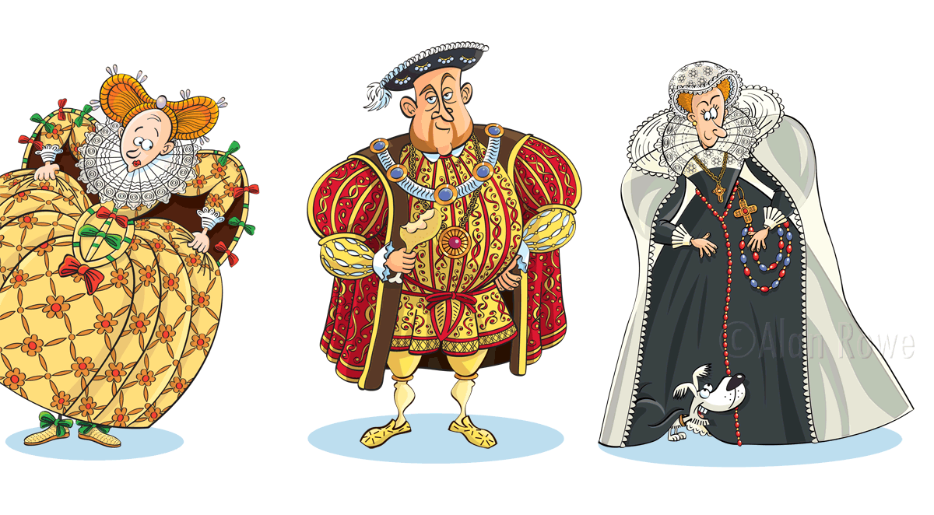

Hi All
Hopefully you have been enjoying the transition work which was set to help you immerse yourself into the world of the Tudors. It is now time to start preparing for the specific content of the course which we will begin in September. Each activity should take around an hour.
Hope you enjoy – feel free to email me if you have any questions,
Mrs Ward
What to bring in September:
- A Lever Arch file with at least 10 dividers
- Highlighters (we use these a lot in History)
- Your 2 core text books (below)
Work to be handed in, first lesson back in Sept:
- A Lever arch file with this pack and the work you have done in it for activities 1-6
- Activity 8 – your 500 word essay
- Activity 9 – your revision notes for this section of the course
The reason we are asking you to do this is because we won’t have seen how you can perform in the GCSE examinations we want a good idea of where you are so we can give you the best, most tailored support when you are starting your A Levels. This will give us a picture of your note-taking / essay writing and revision skills
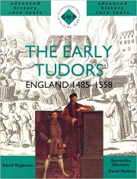
Books to buy for The Tudors:
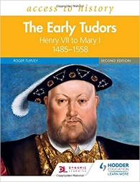
- The Early Tudors: England 1485-1558 (SHP Advanced History Core Texts), by David Hudson (Author), David Rogerson (Author), Samantha Ellsmore (Author)
- Access to History: The Early Tudors: Henry VII to Mary I,

PLC Paper 1c: The Tudors – Henry VII Check lists: Sept – Jan – An overview of the course as a whole

TOPIC | I can explain… | Red | Amber | Green
Part 1: Henry VII - Consolidation, government and domestic policy
Summer Prep – CONTEXT – What was life like in Medieval England?
How did Henry VII come to power?
- Henry VII’s consolidation of power immediately after Bosworth | - Henry VII’s character and aims
 | - Early actions: dating of the battle, Elizabeth of York marriage and Tudor propaganda, parliament, rewarding followers
- Dealing with early threats | - Dealing with the nobility, rewards and sanctions
 | - Dealing with early rebellions, Lovell and Stafford, Lambert Simnel and the Battle of Stoke, The De La Poles
- Government | - Changes to National government – structure, new men, Privy Chamber, chamber system, Gentlemen of the chamber, Great Council, Council Learned, royal court and household, Parliament
 | - Local government: structure, JPs, importance of local control
4. Finance (domestic policy) | - Ordinary revenue
 | - Extra-ordinary revenue
TEST ON SECTION 1 | RESULT: %
TARGETS:

TOPIC | I can explain… | Red | Amber | Green

Part 2: Foreign Policy, Society & Rebellions, Trade and the Economy
5. Foreign Policy | - Henry’s aims
 | - Relations with France and Brittany
 | - Relations with Burgundy, The Netherlands and the Holy Roman Empire
 | - Relations with Spain
 | - Relations with Scotland
 | - Relations with Ireland
 | - The impact of Marriages and Death on foreign policy
6. Society &Rebellions | - The structure of Society – the great chain of being
 | - The Lambert Simnel Rebellion and its foreign policy implications
 | - The Perkin Warbeck Rebellion and its foreign policy implications
 | - What did the commonwealth do if they disagreed with the government? The Cornish and Yorkshire Rebellions
7. Trade and Industry, Exploration, Prosperity and depression | - Agriculture, different types of Industry in England, cloth, coal, tin.,
 | - Merchant Adventurers, Hanseatic League, Navigation Acts, Intercursus Magnus and Malus, Treaty of Etaples.
 | - Exploration, Cabots new discoveries.
 | - Prosperity and depression – what impact did trade and industry have on the economy?
TEST ON SECTION 2 | RESULT: %
TARGETS:

TOPIC | I can explain… | Red | Amber | Green
Part 3: Religion, Humanism, the Arts and Conclusions
8. Religion in England | - The structure of the Catholic Church, beliefs of and people in the church, religious orders, social role
 | - Opposition to the established church – anti-clericalism, Lollardism and heresy
 | - Humanism, the Arts; Drama, Music, art and architecture. Education
9. Conclusions | - Living graph – successes and failures of Henry VII, conclusions
 | - Change and continuity, key course questions

ACTIVITY 1
Read the following information and then in the graphic organiser which follows it make notes on:
1/ The Wars of the Roses
2/ The Reign of Edward IV
3/ The Reign of Richard III
4/ Life in late Medieval England
5/ Late Medieval Government
6/ The Feudal System
A Guide to Late Medieval History

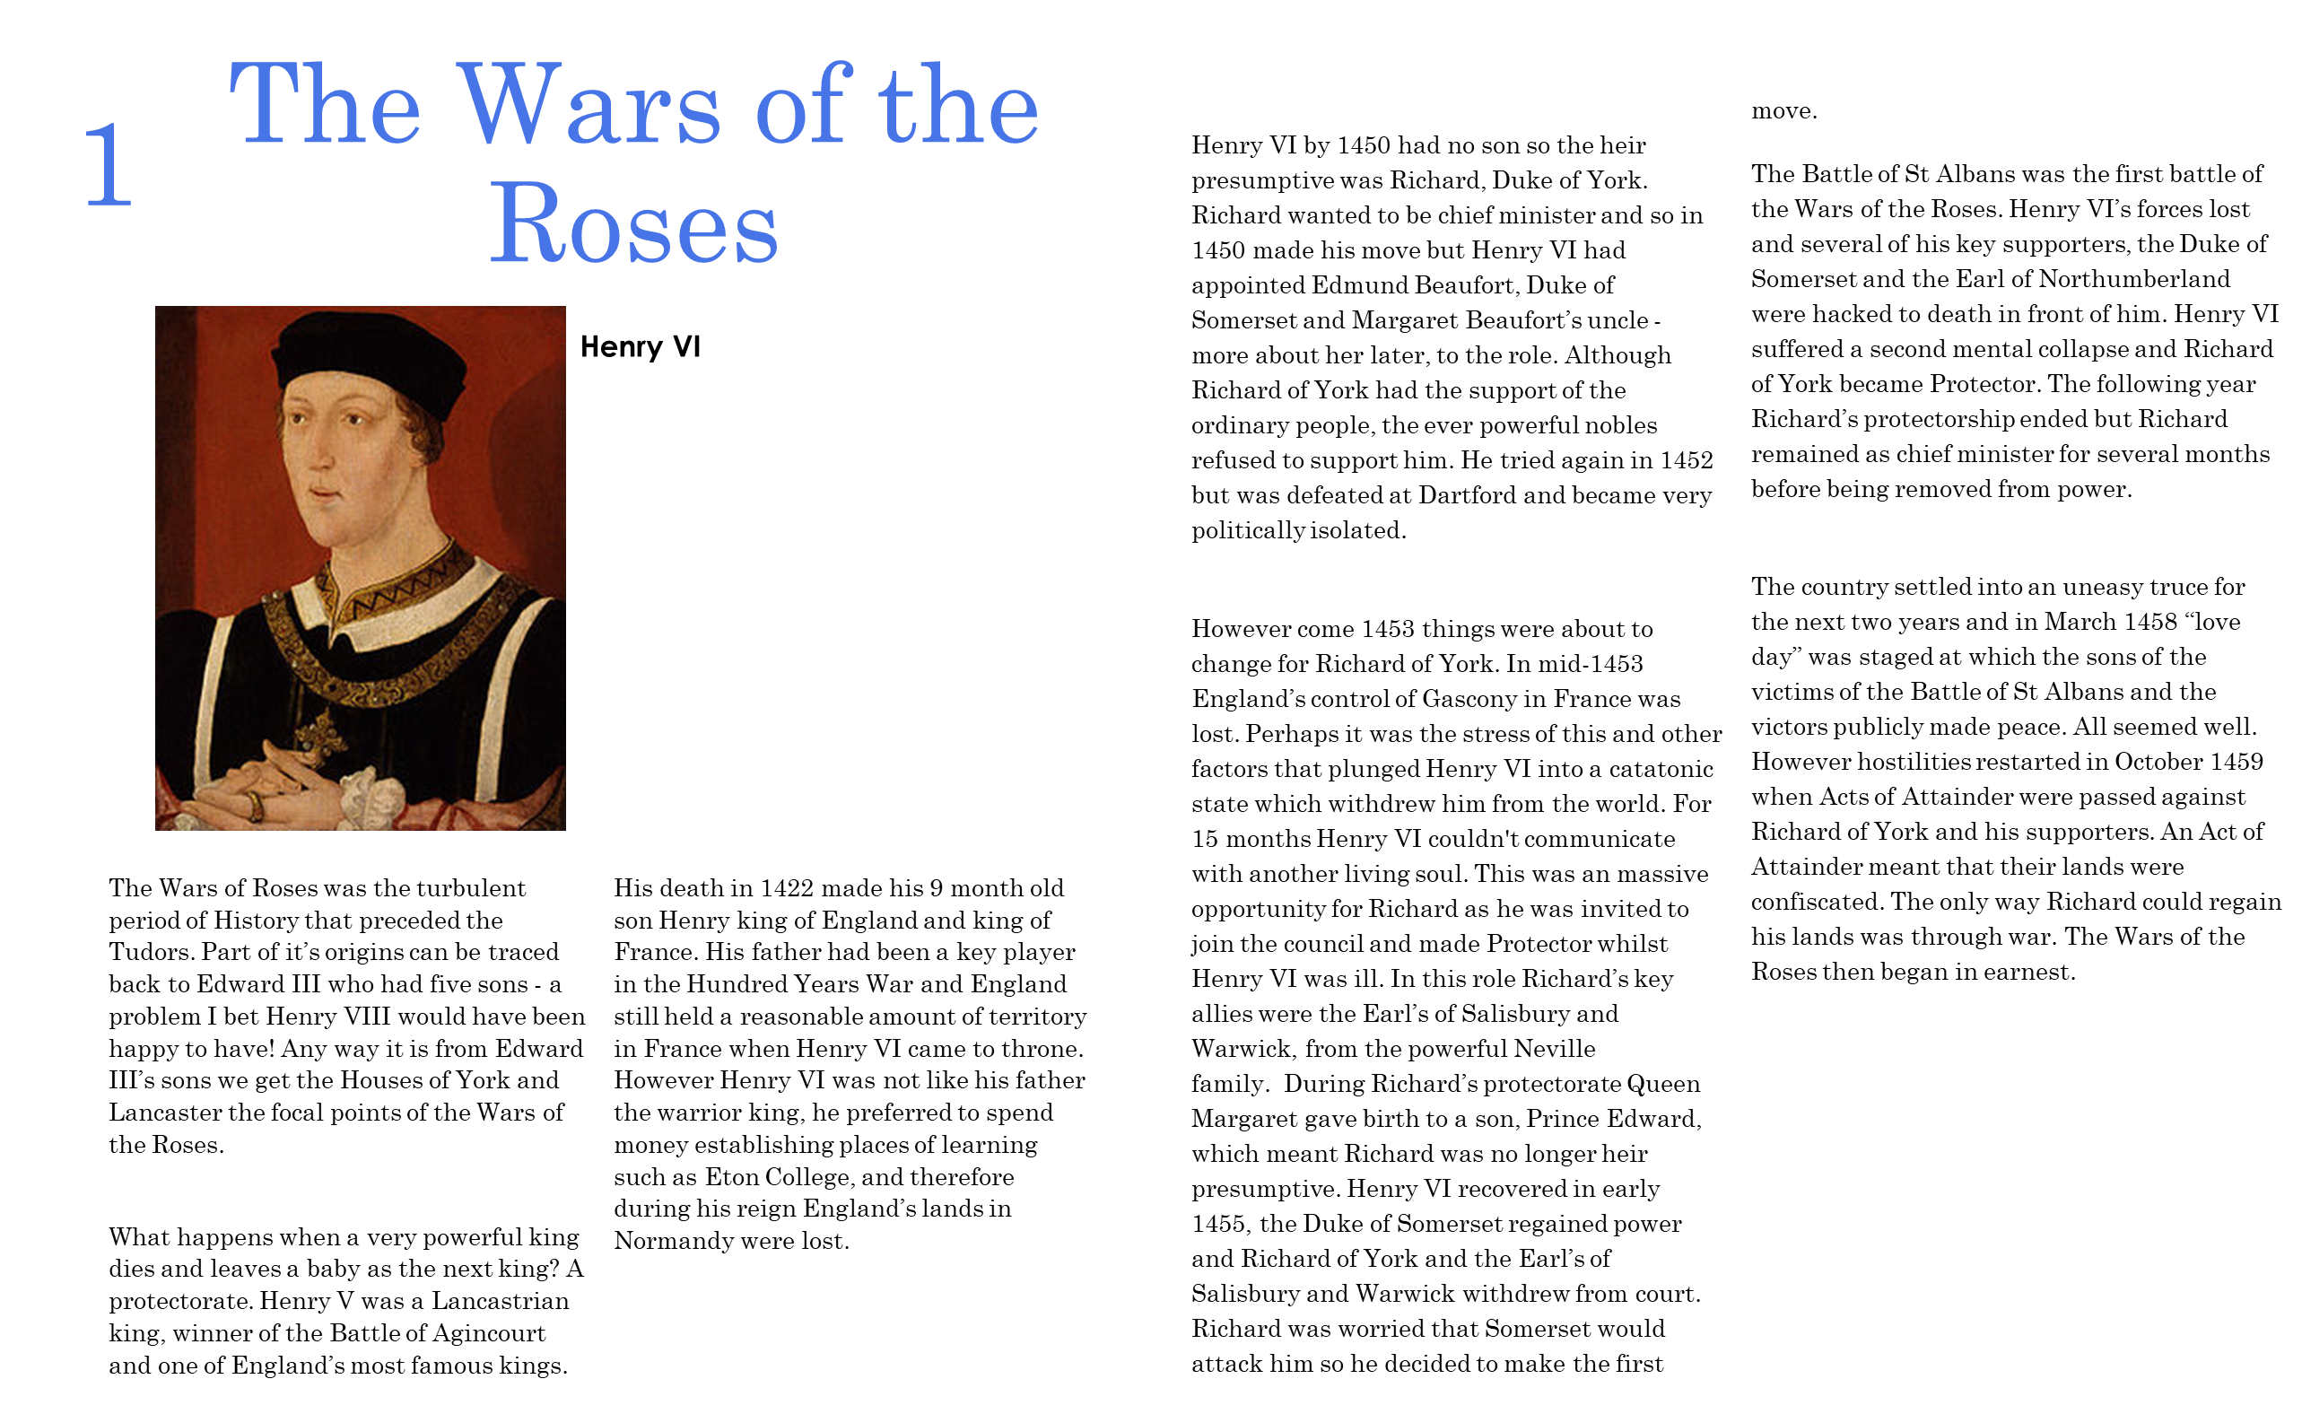

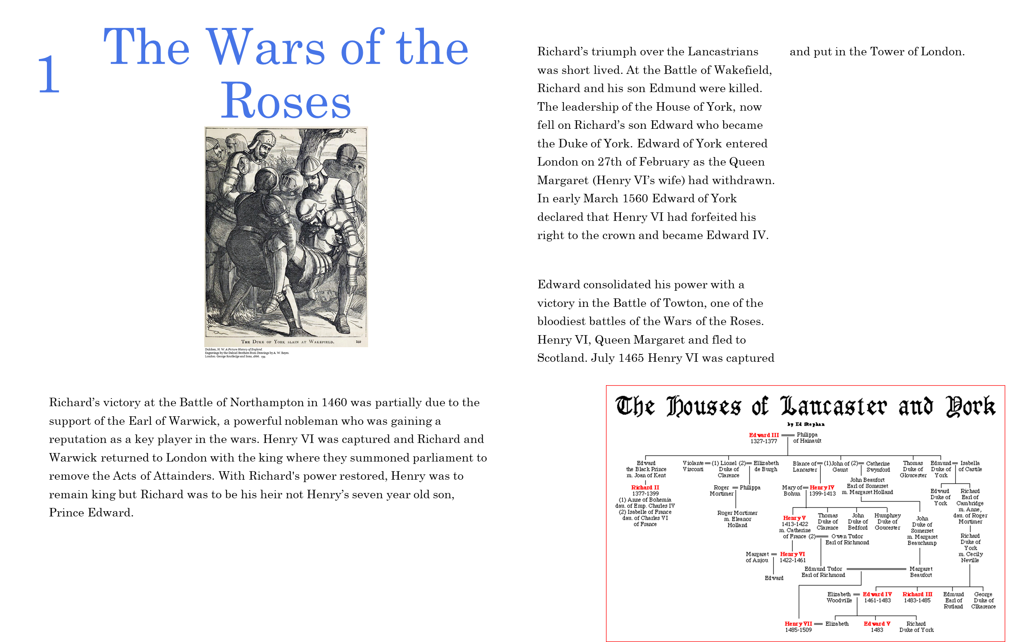

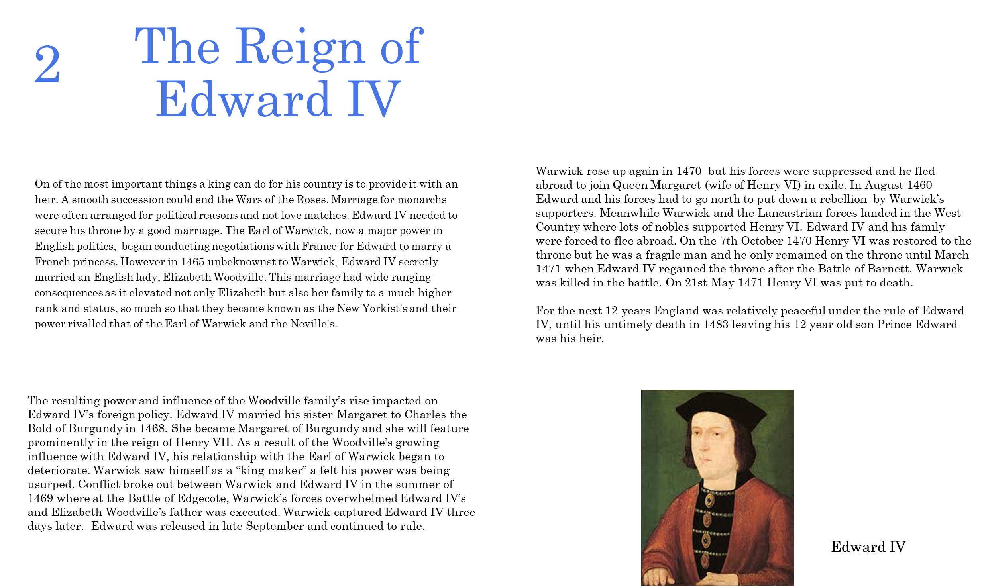
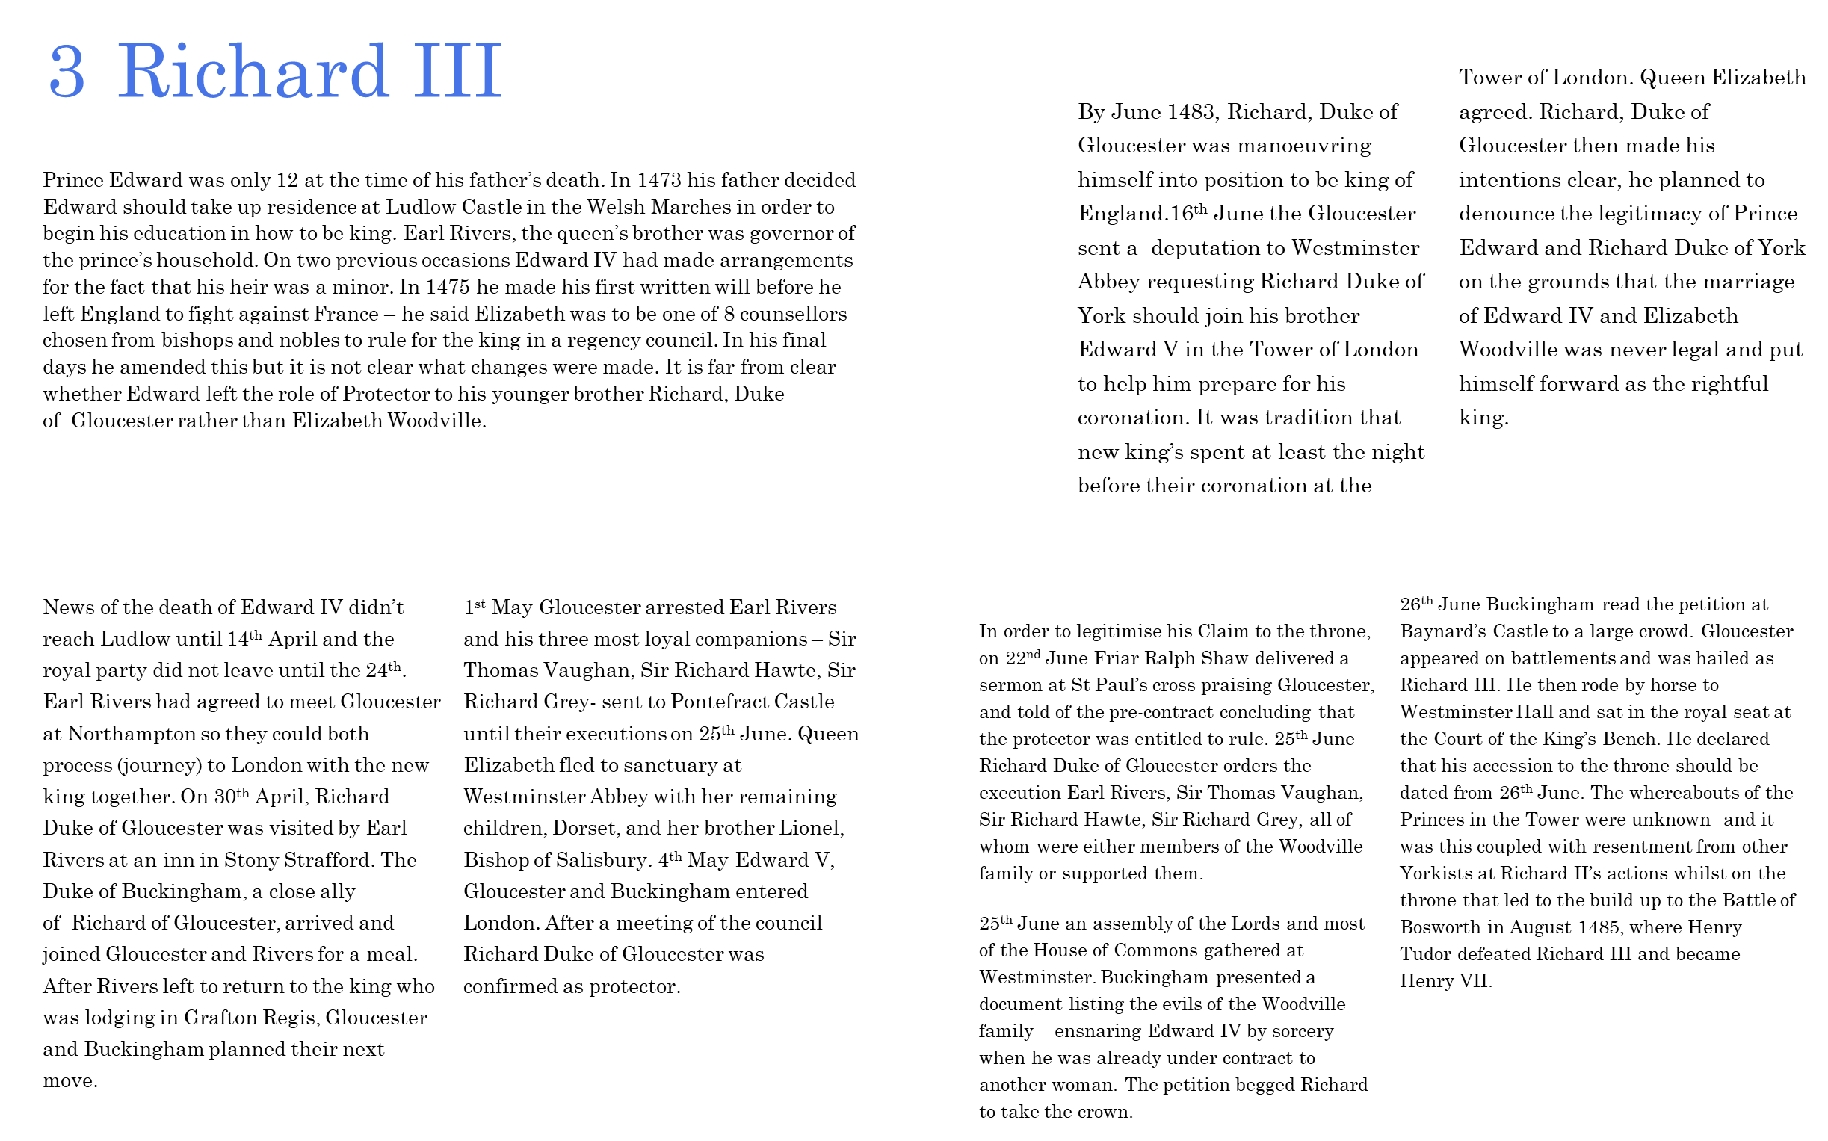
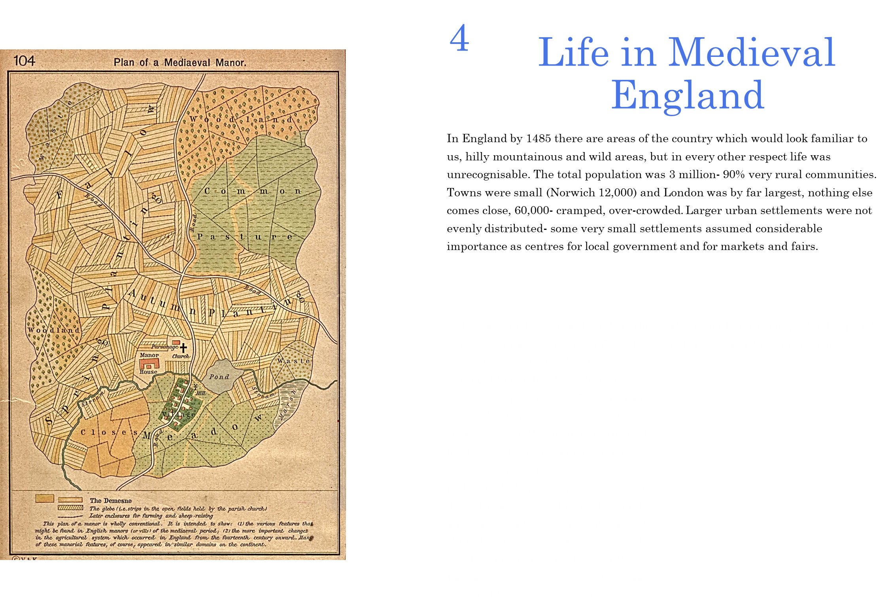
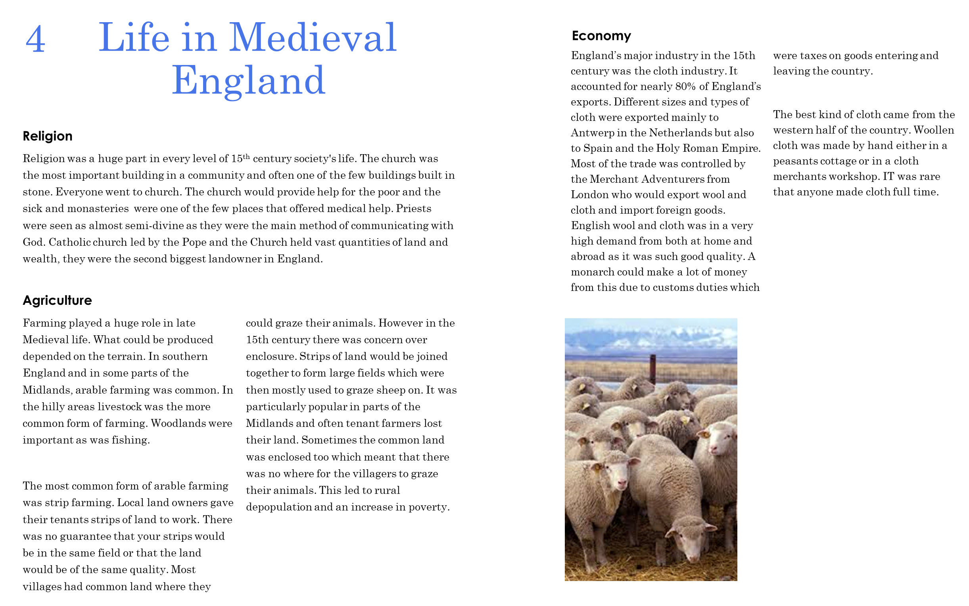
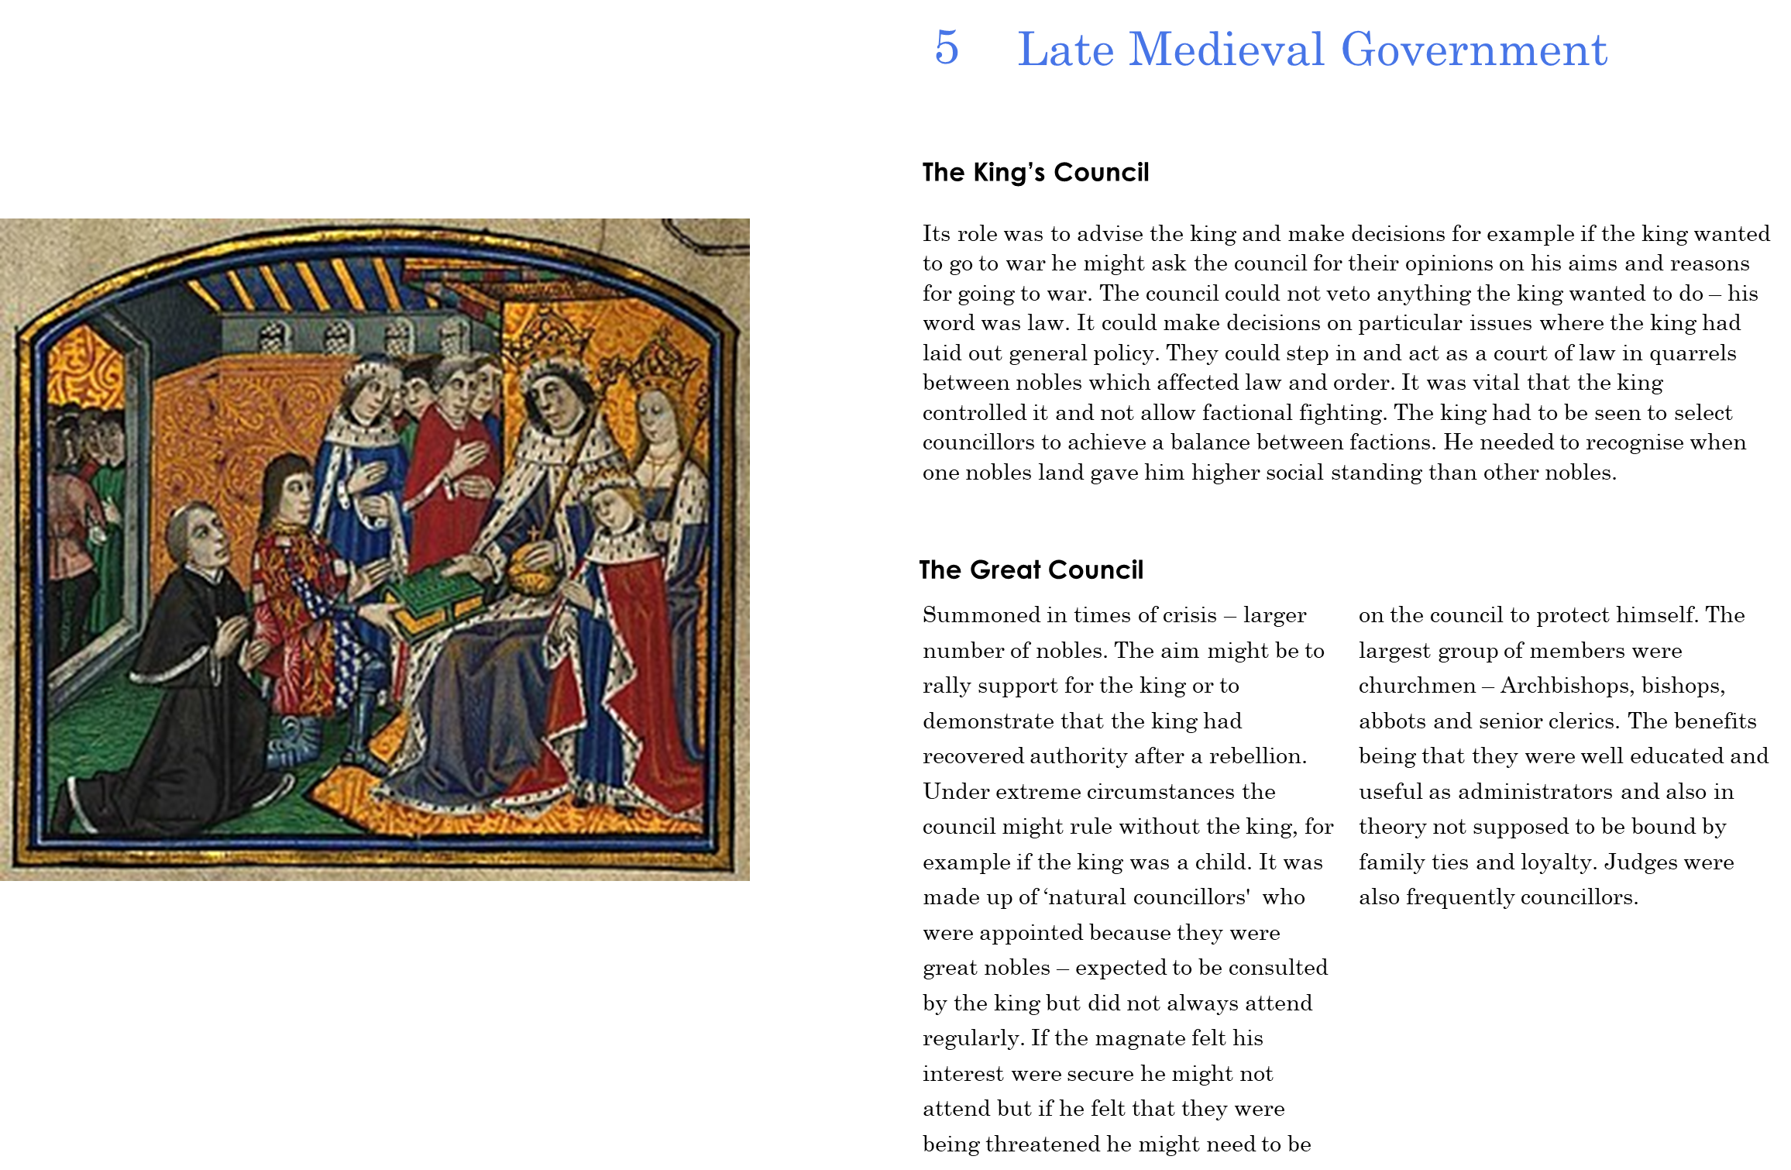
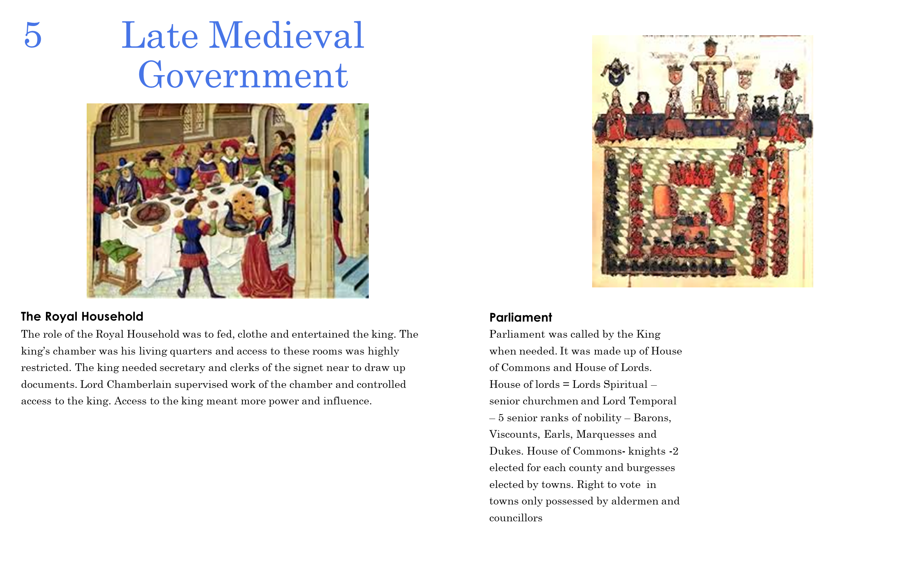
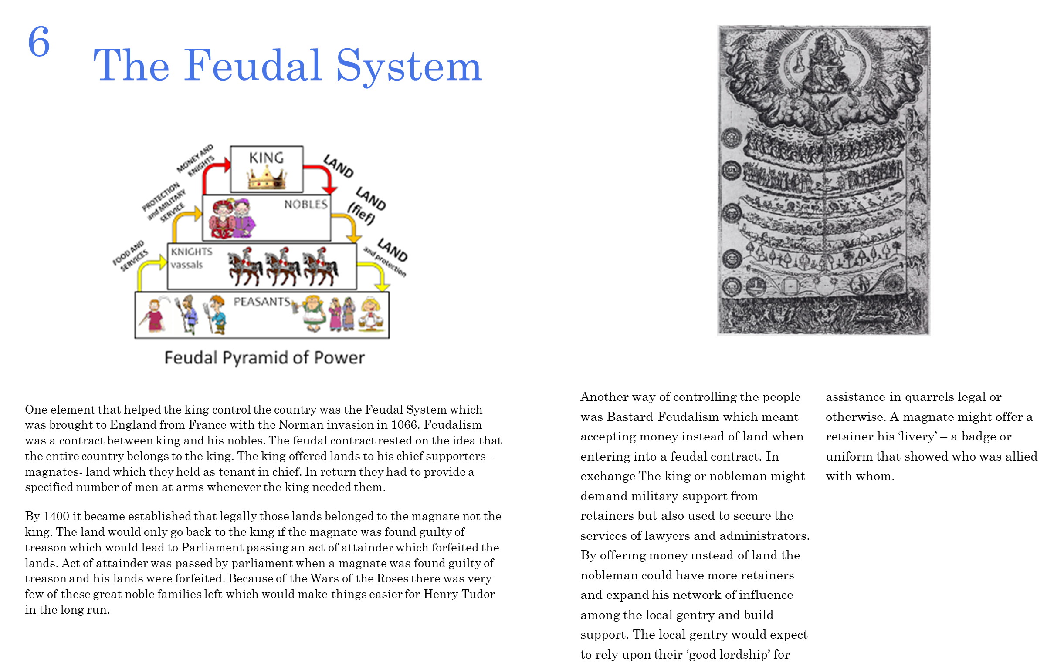
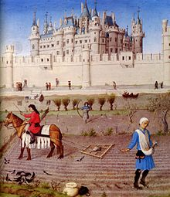
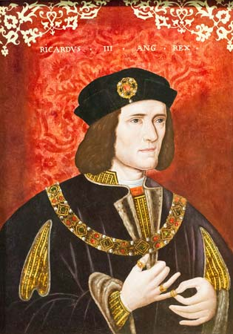
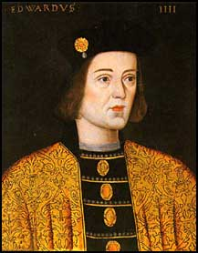
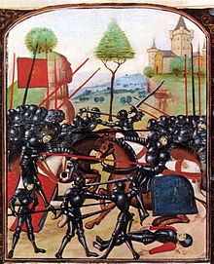

- The Wars of the Roses
2. The Reign of Edward IV
4. Life in Late Medieval England
3. Richard III

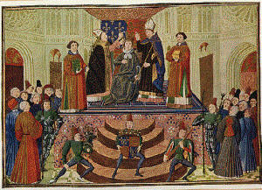
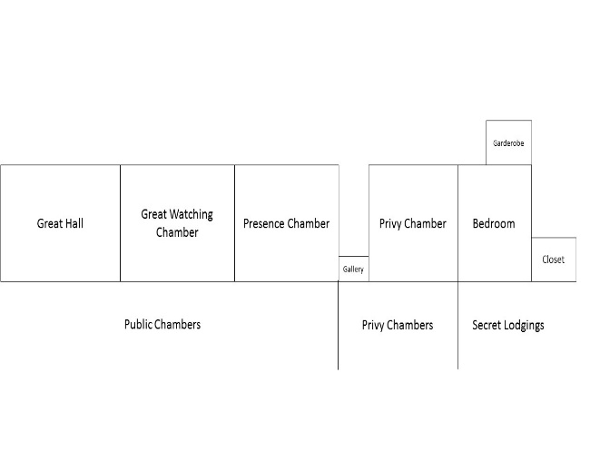
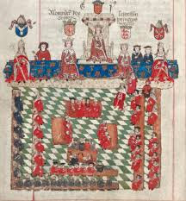
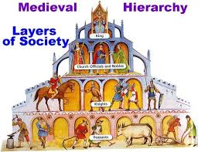

5. Late Medieval Government
King’s Council

Great Council

5. Late Medieval Government
Royal Household
5. Late Medieval Government
Parliament
6. Feudal System

As you can see, there are certain themes which run through this course, Consolidating the power of the crown and the succession, Society and the people, Government, Foreign policy, The economy, trade and exploration, as well as Religion. The Wars of the Roses meant that the nobility became very powerful and could strongly influence who was the Monarch and what they could do. It also led to something called ‘Bastard Feudalism’ where nobles paid men with jobs and patronage to support them at court and on the battlefield. Other key second order concepts we look at are causation change and continuity.
Make a list below of the problems in late medieval England:

If you inherited the throne – what would you want to change, as the monarch?

Activity 2:
Henry VII – Introduction
You may already have done this as part of the bridging work – if you have – WELL DONE – move on to Activity 3 – if not – time to do it now!
Make notes on THE WINTER KING DOCUMENTARY:
This is an overview of Henry VII’s life and conquest of England
Watch the following documentary on youtube: https://www.youtube.com/watch?v=-5FsriGn300
You need to complete the following using the information in the documentary
Family
Background

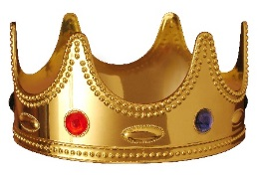


Bosworth
First Actions as King

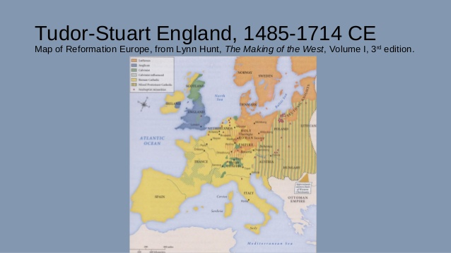
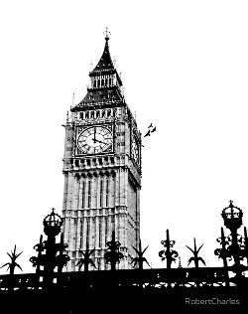
Foreign Policy Problems

Political problems

Activity 3:Watch this summary video: https://www.youtube.com/watch?v=R-WIiBUmRAEMake a list of the ways Henry VII consolidated his success at Bosworth and claim to the throne.
Mini-essay
How successfully did Henry VII consolidate power early in his reign? – Use the graphic organiser below ‘Consolidation & controlling the Nobility’ and in 500 words explain the different ways Henry consolidated power after the Battle of Bosworth

H7: Consolidation & controlling the Nobility  KNOWLEDGE ORGANISER  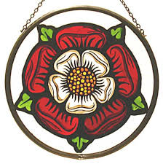 | Immediate Steps to Consolidate after Bosworth | Immediate Threats - People | Controlling the Nobility through reward | Controlling the Nobility through threat and punishment | The Order of the Garter
 | 1. Dated his reign from the day before the battle of Bosworth  2. Had his coronation BEFORE the first Parliament sat so he claimed the throne himself rather than allowed Parliament to declare him King  3. Applied for papal dispensation to marry Elizabeth of York and unite the two house.  4. Created the Tudor Rose combining the Tudor and Lancastrian houses. | 1. Edward, Earl of Warwick, the nephew of Richard III (son of Clarence who was murdered by his own brother Edward IV) - imprisoned in the tower.  2. John de la Pole, named by Richard III as heir to the throne - had sworn an oath of loyalty to Henry VII – executed after Battle of Stoke  3. Richard de la Pole – exiled  4. Edmund De La Pole – Duke of Suffolk – accused of murder ends up in exile | 1. The Order of the Garter.  2. Offices such as Chancellor of the Exchequer to Thomas Lovell.  3. Patronage.  4. Positions on the King's and Great council  5. Crown lands - Henry did not hand out crown lands in order to maximise crown revenue | 1. Acts of Attainder - forfeiting money and land and titles.  2. Bonds and recognisances - written agreements for promises of good behaviour, with a financial penalty if broken and a formal acknowledgement of a debt or obligation, which pre-existed and the promise of money if the obligation was not met.  3. Feudal dues - making the nobility pay for wardships / marriages / livery /escheats / relief.  4. Retaining - where nobles retain or recruit gentry to support them – H7 wanted this limited and punished those who excessively retained. | The Order of the Garter was established under Edward III. It was a useful way to recognise service without having to give money or lands.  37 men received it in H7’s reign including Rhys ap Thomas (who was v. pleased) and Stanley (who felt it was slight reward for his support)
Patronage | Acts of Attainder | Bonds & recognisances | Feudal Dues | Livery & Maintenance | Retaining
H7 reversed the use of patronage, he did not use it to secure the goodwill of the nobility but only gave it in reward of good service. His criteria for who should receive it was based on loyal service and not on importance / nobility so ‘New Men’ gained positions of power in government. This was essential to H7’s policy to control his government as these men did not derive power fromt heir lands but directly from H7’s patronage therefore they were loyal to him | Parliament passed to declare a nobleman guilty of a crime against the Crown, usually treason. The noble might be imprisoned, and the attainted family lost the right to inherit lands and titles. Reversible.  Duke of Norfolk attainted and after Bosworth. Released and restored to the earldom of Surrey in 1489 to suppress uprising in Yorkshire.  1485-6:28 people  1487:28 people  1495: 24 people | A bond recognised that a person owed a lump sum which was not payable if the condition (good behaviour) was met.  A recognisance was when a person formally acknowledged a debt or obligation.  Marquis of Dorset had to give a bond after his suspected involvement in the Simnel plot. It guaranteed future loyal conduct.  Lump sums payable from bonds:  1493-4, £3,000  1504-5: £75,000 | Nobles owed H7 certain dues as King and their feudal Lord. Wardship – H7 took control of land when a minor inherited it and oversaw it until that minor came of age. He took most of the profits made from that land. So a wardship could be lucrative.  Marriage when the king could give unmarried heirs and heiresses in marriage but at a profit for himself.  ‘Relief’ – money H7 received when inherited land was transferred.  H7 enforced feudal dues even tho’ seen as outdated by 1485. In 1487, wardships provided Henry with just £350. By 1507, with a Master of the King’s Wards in place to enforce it, wardships were earning Henry £6,000 a year. | 1. The Act of Livery, passed in 1503 - passed in 1502, banned the keeping of private armies.  2. The Statute of Maintenance  prevented nobles from:  - Bribing judges and juries  - Frightening judges and juries into giving false decisions, by filling the court room with retainers.  - Causing riots  - Holding unlawful meetings | 1487 & 1504 H7 passed Acts against retaining – an indication of periods where he felt vulnerable (post Battle of Stoke and death of Arthur)  Evidence of H7’s success in controlling the nobility was the reduction in retaining.  Some nobles employed more ‘estate officials’ than were necessary getting round the legislation. However Lord Bergavenny was fined £5 per retained (the statutory amount) and was find £70,550 – a bankrupting amount of money. H7 even fined his own mother for retaining! H7 did not eradicate it but controlled it effectively.
Council Learned in Law |  | Court of the Star Chamber |  | Key People
Replaced use of the Star Chamber (1487) to control the nobility.  A ‘specialist board’. Its function was to maintain the king’s revenue and exploit his prerogative rights.  Led by Bray until he died in 1503, then Empson & Dudley. Historians have often seen their work as ‘shady’ due to not being recognised as a court of law and those who were summoned had no appeal. |  | Brought to trial any nobles who had broken the Act of Livery and Maintenance. The Judge would be the king himself! There would be no jury. Henry himself would hear the evidence and decide a verdict. Noblemen were fined heavily, and often had their lands confiscated (this made nobles poorer, and H7 richer). Even H7’s friend the EARL OF OXFORD was fined £15,000 for breaking the Statute of Livery and Maintenance |  | Reginald Bray – Council Learned  Richard Empson – Council Learned  Edmund Dudley – Council Learned  John Morton – Archbishop of Canterbury  Richard Fox - Bishop  William Stanley - Lord Chamberlain  Jasper Tudor – control of Wales  Thomas Stanley – the North  Earl of Northumberland – the North  Earl of Surrey – the North
Summary: - Overall, was successful. He took back all the land that had been given away by previous kings and with their power broken, he appointed nobles to important positions that he felt he could trust, so Henry was richer and safer

Medieval Kingship
Tudor government is a period in which the foundation of modern government was established. There is a significant amount of historical debate over the extent of change and continuity in the Tudor period. Listen to this podcast and make notes on the changing nature of Government under the Tudors. https://www.bbc.co.uk/programmes/p00546xd Melvyn Bragg discusses the role of the Tudor dynasty in reshaping the British state and whether their government of England laid the political foundations of our own age.

