Classical Civilisation A-Level
Summer Holiday Prep
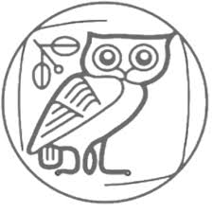
Well done for choosing Classical Civilisation A-level!

Set texts to purchase
These key texts will be studied in our lessons. We ask you to purchase your own copies so that you can annotate them (but please let Mr Arden know if that presents any difficulties).

FOR SEPTEMBER:
- The Odyssey, Homer, translated by E.V Rieu (Penguin) ISBN: 9780140449112
- The Odyssey: York Notes Advanced ISBN: 9780582431515
- Oedipus the King, translation by Fagles, in The Three Theban Plays (Penguin) ISBN: 9780808577126
FOR LATER IN Y12:
- Bacchae, Euripides, Cambridge Translations from Greek Drama ISBN: 9780521653725
- Frogs, Aristophanes, Cambridge Translations from Greek Drama ISBN: 9780521172578
FOR Y13:
- The Aeneid, Virgil, translated by D.West (Penguin) ISBN: 9780140449327
- The Aeneid: York Notes Advanced ISBN: 9780582431546

Classical Civilisation – part of Classics at JCoSS

In Classical Civilisation (“Class Civ”) we cover several aspects of Greek and Roman literature and culture, in English translation. The other Classical subject we offer at JCoSS is Latin (some schools also offer Classical Greek).

“Classics” is the umbrella term for all these subjects, used particularly for university courses. It covers all aspects of the ancient world: Greek and Latin languages, literature, history, politics, philosophy, science, art, archaeology and linguistics. It is a great choice of degree if you want to gain experience of a wide range of disciplines!

You’ll find below a timeline to give you some perspective – we will cover from the Trojan Wars on the left up to (roughly) the destruction of Pompeii by Vesuvius on the right.

Why do we study these cultures that ended so long ago? The simple answer is because they laid the foundations for modern Western civilisation, and they give us a unique insight into our own world.

(Why does the USA have a Senate? Because the Romans did too. Why do our public buildings have columns around the outside? Because Greek and Roman ones did, too. Why do we go to a theatre and watch a comedy or tragedy? Because the Greeks invented that whole idea. Why is AU the chemical symbol for gold? You get the picture…)

Watch Ian Hislop talk about this: https://www.youtube.com/watch?v=ieXlOBHHad4

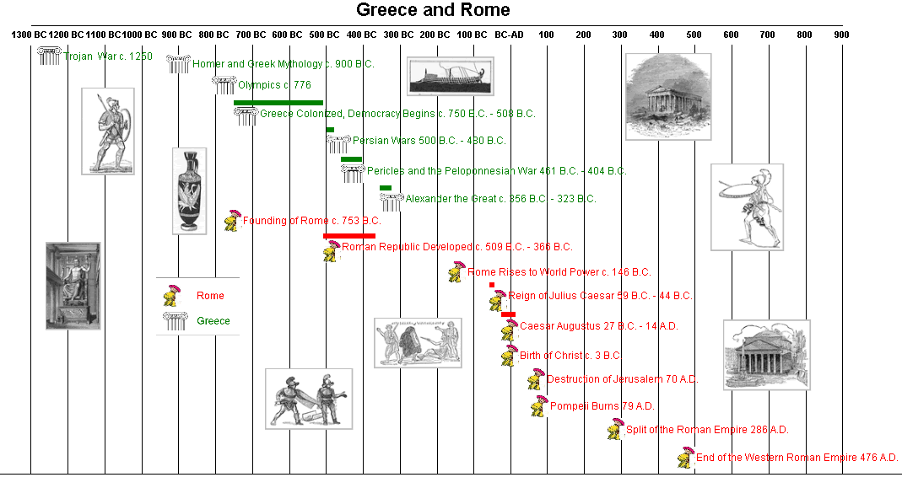

The Greek and Roman civilisations were distinct but closely related. The Romans came later and were technologically more sophisticated (think of all those baths and aqueducts), which gave them great military success and a vast empire (including Greece). For culture, however, they relied on the Greeks who were brilliant artists and public speakers, and had invented theatre, and disciplines like philosophy and science. A good example is the pantheon of Greek gods – the Romans liked what they saw, so they borrowed them all “lock stock and barrel” and just renamed them.

You could draw an interesting parallel with the UK and the USA – which is more like Greece, and which is more like Rome?

Watch these short National Geographic videos about the Greeks and the Romans:

https://www.youtube.com/watch?v=6bDrYTXQLu84
https://www.youtube.com/watch?v=GXoEpNjgKzg

In Y12, with the Odyssey and Greek Theatre, we will focus more on the Greek world, then in Y13 (with the Aeneid and Love and Relationships) we will add a Roman perspective.

Bridging work for Greek Theatre
Drama as we know it appeared and flourished in an amazing period of creativity in Athens in the 5th century BCE (alongside democracy, philosophy, rhetoric and art). To fully appreciate the plays we read, you will need to understand Athenian culture and society, as well. Here is a short clip about daily life: https://www.youtube.com/watch?v=ar8S6virCwM

- Watch the first two episodes of “the Greatest Show on Earth” by Michael Scott (1 hour each) and note down FIVE things of interest from each episode. Bring your notes to your first Greek Theatre lesson with Mr Arden:

https://www.youtube.com/watch?v=FAkLTWQUbG8
https://www.youtube.com/watch?v=l1nqlhgtzUo
- Go to a play or an opera, or watch one online – Classical or not. Come to class ready to tell us about it, and to explain what you enjoyed and what you would have done differently yourself.

Bridging work for World of the Hero

TASK 1
Come up with an answer to the following question and come prepared to share it in your first lesson with Mrs Trup:
If you were a character from Greek or Roman antiquity (- either real or fictional), who would you be and why?

TASK 2
Consider this question and jot down some ideas ready to share in class:
If you were to find yourself out at sea for ten years, far from home, reliant on the hospitality of strangers….
- how would you feel?
- what would you worry about?
- what would you hope to gain from the experience?
- how would your loved ones feel?
- what might they do?
- what challenges might you face on your ultimate return home?
- How might you overcome these?

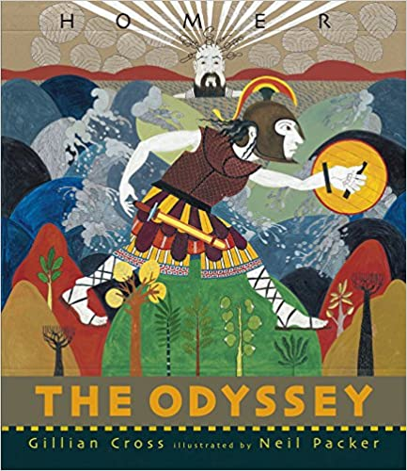
TASK 3
Watch the TEDEd video Everything you need to know to read Homer's "Odyssey" and bring along to our first lesson your answers to the following questions:

- Why is the fact that we can read the Odyssey at all ‘pretty incredible’?
- What does the video tell us about Homer?
- What does it tell us about how his works developed over time?
- What is the meaning of the word ‘rhapsode’ and how does that help us to understand the nature of oral poetry?
- What features helped rhapsodes to be able to recite oral poetry?
- What are the names of the two Homeric epics?
- What theme unites these two works?
- What is the Greek pantheon a dangerous mix of?
- What are many of the problems faced by humans in the poems due to?
- What is meant by ‘xenia’ and what did it involve?
- How does the theme of xenia feature in the Odyssey?
- How does the Odyssey begin?
- How do we find out about Odysseus’ wanderings?
- What, according to Jill Dash, is one of the most fascinating things about the Odyssey?

Wider preparation

- Many ancient myths have recently been reimagined by contemporary writers such as Margaret Atwood (the Penelopiad), Pat Barker (the Silence of the Girls) and Natalie Haynes (Pandora’s Jar) – go to a library or bookshop and explore!

- The British Museum has one of the world’s greatest collection of Greek and Roman artefacts – pay a visit to check out the sculptures, vases and everyday items on display. Sir John Soane’s Museum is nearby and worth visiting to see how Classics inspired one of Britain’s most brilliant architects.

