Year 11 bridging work for Sociology A Level
Welcome to Sociology A level!
As part of your course you will be learning, reading, writing and researching about a wide range of societal issues in relation to a variety of social institutions and varying social groups.
In order to prepare you for the course you need to complete the following:
- Chose and read one book from the six choices on the second page of this document. There are 3 different themes: Ethnicity, social class and gender, so choose the one that most interests you.
- Once you have chosen and read your book you then need to complete one of the following tasks in response and bring this ready and finished with you for your first lesson in sociology in September.

Project choices

- Photography: Take 5 photos in response to your chosen book and the societal issues it uncovers. These photos need to be printed, with a 100 written piece explaining why they represent the theme covered in your choice of text.
- Book review – 250 written piece. What theme did your author cover? Why is this issue so significant in a contemporary society? Do you agree/disagree with the authors thoughts? Explain why. Do you think the government is doing enough to respond to this issue?
- Podcasting response – 3 minute response to your chosen book. This can be in conversation with someone, or on your own.
- Debate in class in response to the book: As a response to your chosen text, you may want to debate a theme or argument from the book. For example, if your book covers the issue of democracy and freedom in society you might want to debate the point “Everyone has equal chance of success in society”. You will only have 5 minutes to debate your chosen statement in class, so consider stem questions that you would like to consider too.

If you have any questions please do not hesitate to contact Mr Gunessee or myself via Teams or email up until the 22n^{d} July about this project we will not be able to respond to you after this date.

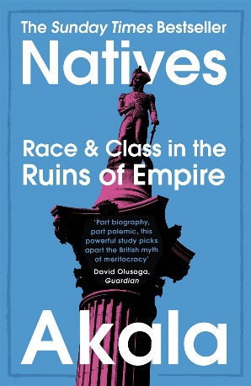
Ethnicity
Natives: Race and Class in the Ruins of Empire is a 2019 British book by the rapper Akala. Part memoir, the book provides race and class analysis of a variety of historical eras, in addition to contemporary British society.
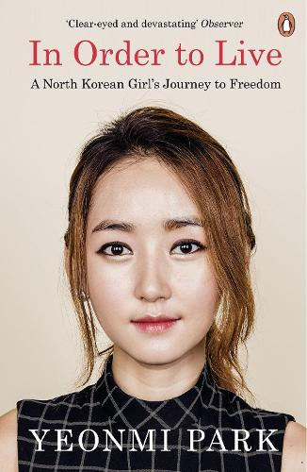
Yeonmi Park was not dreaming of freedom when she escaped from North Korea. She didn't even know what it meant to be free. All she knew was that she was running for her life, that if she and her family stayed behind they would die? From starvation, or disease, or even execution.

Social class
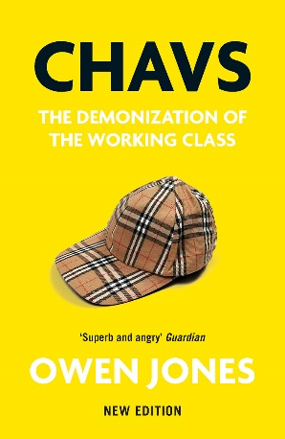
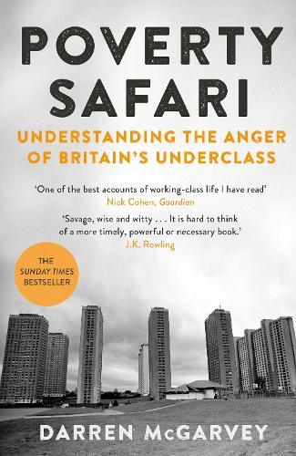
Chavs: The Demonization of the Working Class is a non-fiction work by the British writer and political commentator Owen Jones, first published in 2011. It discusses stereotypes of sections of the British working class and use of the pejorative term chav.
Winner of the Orwell Prize 2018.Named the most 'Rebellious Read of the 21st Century' in a Scottish Book Trust poll. Darren McGarvey has experienced poverty and its devastating effects first-hand. He knows why people from deprived communities all around Britain feel angry and unheard.

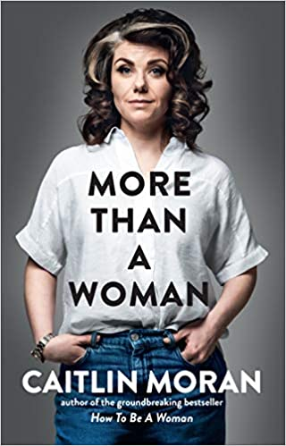
Gender
How to Be a Woman returns with another “hilarious neo-feminist manifesto” (NPR) in which she reflects on parenting, middle-age, marriage, existential crises—and, of course, feminism.
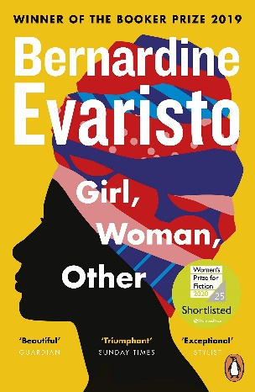
Girl, Woman, Other is the eighth novel to be written by Bernardine Evaristo. Published in 2019 by Hamish Hamilton, it follows the lives of 12 characters in the United Kingdom over the course of several decades.

