Latin A-Level
Summer Holiday Prep
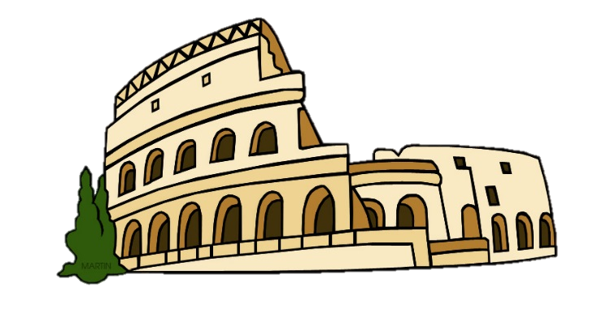
Well done for choosing Latin A-level!

Set texts to purchase:
These key texts will be studied in our lessons. If you are able, please purchase a copy of these for your summer work.
- Latin Beyond GCSE, J. Taylor (Bloomsbury) ISBN: 9781474299886
- Cicero, Pro Cluentio: A Selection (Bloomsbury) ISBN: 9781350060340
- Virgil, Aeneid XII: A Selection (Bloomsbury) ISBN: 9781350059214
Please also purchase a large A4 ring binder and create dividers for the following topics:
- Language Work – Prose Composition and Comprehension. Include in this area of your folder all of your grammar notes from your study of Latin Language at GCSE.
- Unseen Translation – Ovid
- Unseen Translation - Livy
- Virgil
- Cicero

Bridging work for Latin Language
- Please use your Latin exercise books/worksheets/booklets from your study of Latin up to GCSE to revise the following linguistic features from your GCSE language work. You will be tested on them during the first week of lessons. Feel free to revise your GCSE grammar using volume 3 of the CLC on the Cambridge Latin Course website:

Key Grammar:
- Nouns: all standard types of all 5 declensions -
- Verbs: present, imperfect, perfect and pluperfect indicative active
  - imperfect and pluperfect subjunctive active
  - 3rd person singular and plural present and imperfect passive
- Constructions that take the subjunctive and how to translate them

  - Book 3 Online activities: https://www.clc.cambridgescp.com/books/book-iii
  - Book 3 Online textbook: https://www.clc.cambridgescp.com/sites/www.cambridgescp.com/files/legacy_root_files/clc/webbooks/book3/index.html?p=1
  - Suggested activities:
    - Translate stories*
    - Read and summarise grammar notes
    - Complete translation exercises*
    - Learn grammar tables at the back of the textbook
- Get ahead by using volumes 4 and 5 of the CLC on the Cambridge Latin Course website:
- Book 4 Online activities: https://www.clc.cambridgescp.com/books/book-iv
- Book 4 Online textbook: https://www.clc.cambridgescp.com/sites/www.cambridgescp.com/files/legacy_root_files/clc/webbooks/book4/index.html?p=1
- Book 5 Online activities: https://www.clc.cambridgescp.com/books/book-v
- Book 5 Online textbook: https://www.clc.cambridgescp.com/clc/webbooks/book5
- Suggested activities:
  - Translate stories*
  - Read and summarise grammar notes
  - Complete translation exercises*
  - Learn grammar tables at the back of the textbook
- If you would like to complete further exercises using Latin Beyond GCSE, please contact your teacher via email.

Bridging work for Latin Literature
  - Use the set text on Cicero complete the tasks that follow

Questions:
- Summarise the key events of Cicero’s life
- Summarise the context of the trial of Aulus Cluentius Habitus

  - Use the set text and the following sources of information on the Aeneid and answer the questions that follow
Resources:
- Why you should read the Aeneid: https://youtu.be/p4mbk59rbjE
- In Our Time: The Aeneid https://youtu.be/2xIf9k6d1PQ
- https://www.sparknotes.com/lit/aeneid/summary/
- https://www.cliffsnotes.com/literature/a/aeneid/poem-summary

Questions:
- What do we know about Aeneid who wrote the Aeneid?
- Who/what are the key characters, themes and places?
- Chapters in epic poems are referred to as ‘books’. Summarise each book with the three key events.
- What challenges does the protagonist face during the poem as a whole?
- In what ways is the Aeneid similar to the Odyssey and in what ways is it different? Consider events that take place, challenges faced, types of heroes and themes.

Optional: read the Virgil set text in English by using the translation of Virgil Book XI on this website: https://www.poetryintranslation.com/. Create a list of characters and place names by section

Bridging work for Latin vocabulary
Please download and begin learning the list via the web link: https://www.ocr.org.uk/Images/221507-as-level-gce-latin-h043-defined-vocabulary-list.pdf

If you are able to learn vocabulary online, please also sign up for Memrise and sign up for courses on the AS Level list above and also on the following Roman authors:
- Livy
- Ovid
More OPTIONAL tasks
The following texts are not essential to buy, but you may find them interesting to read.
- Some or all of the Cicero Trilogy – ‘Imperium’, ‘Lustrum’ and ‘Dictator’ by Robert Harris – a thorough and thrilling fictionalised romp through the end of the Roman Republic
- ‘Rubicon’ by Tom Holland – an engaging history of the fall of the Roman Republic.
- 'You Talkin' To Me?: Rhetoric from Aristotle to Obama' by Sam Leith – an introduction to Cicero’s oratory and his impact on the modern world.
- Read more of Virgil’s Aeneid, starting from the beginning.

