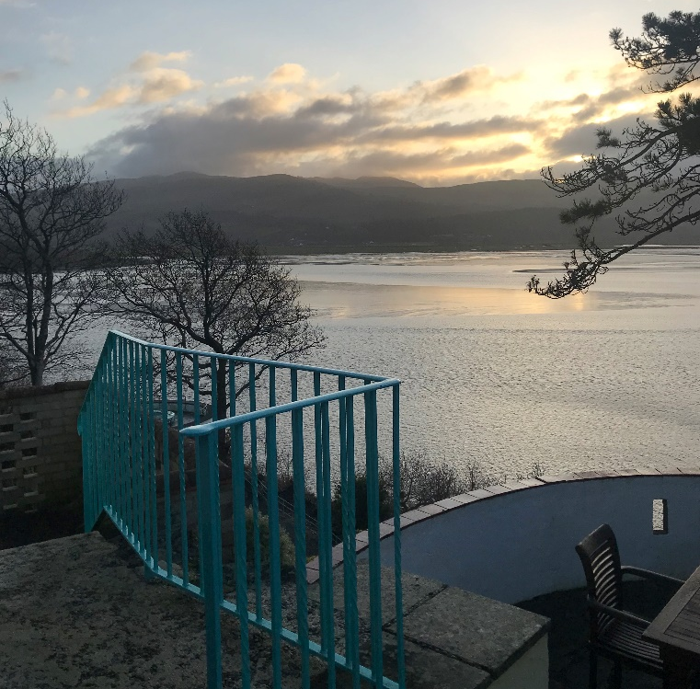
A Guide On Managing Stress & Anxiety
--big and small

These are trying times, and whilst we cannot change what is going on out there, we can work on what’s going on inside ourselves. I’ve put together a resource of 20 tips & techniques to help tackle stress and anxiety during the time of corona (and beyond). Take a look at the ideas below, I hope you find them helpful when you try them.

1. The 5 senses technique
Do this as many times as you need to until you feel calmer.

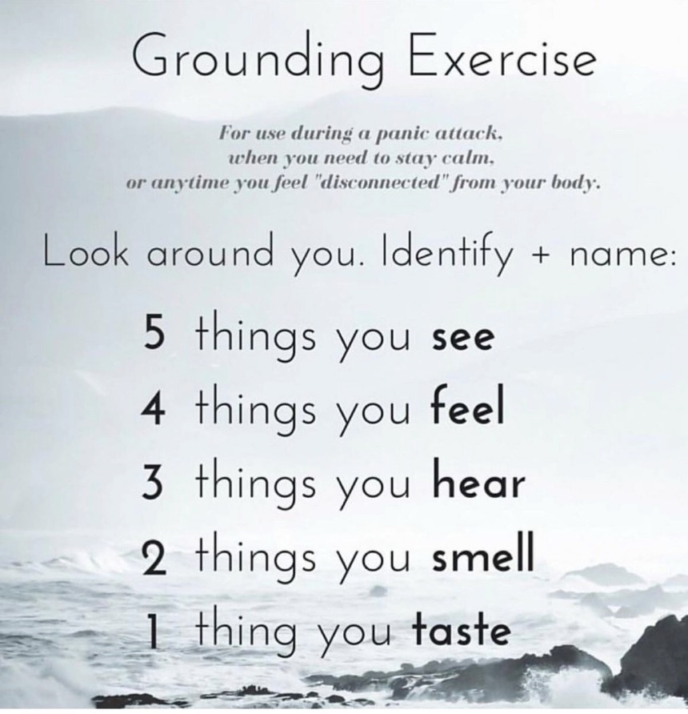

2. Square breathing
Breath in for 3, hold for 3, breath out for 3, hold for 3. Repeat several times.

3. Remember right now
Remind yourself that right now, in this very moment, regardless of what’s gone on in the past or might go on in the future, you are safe and not in any danger. Once that thought is solid, move onto doing something soothing, (there is a list below). The reminder of the right now is useful for when you start to feel anxiety creeping in and are not sure why. It’s not so useful during a panic attack because logic is trickier to access during that so use pre-emptively if possible.

4. Empty your thoughts out
If there are lots of thoughts going on for you at once, try writing them out somewhere separate. You can then choose whether you want to throw them in the bin, put them away somewhere safe, rip them up- whatever feels right for you! You can just know you’ve done something with them rather than just letting them carry on swimming around in your head.

5. Have a bath or a shower
It may sound too simple, but this changes your temperature which can help a shift in your mood to occur, and can also be a way to simply nurture yourself.

6. What’s your score?
Score yourself from 0-10 on your emotional, physical, and lastly, mental energy level. Try to monitor when each of these levels feel higher or lower. You can then take these into account when planning your day.

7. Draw it out
Don’t worry about whether you’re any ‘good’ at drawing or not, it’s much more about freely expressing whatever you’re feelings.

8. Natural oils
Smell some natural oils that are strong (if you have them), such as peppermint, lavender, camomile, lemongrass etc. This also works with types of tea and some flowers.

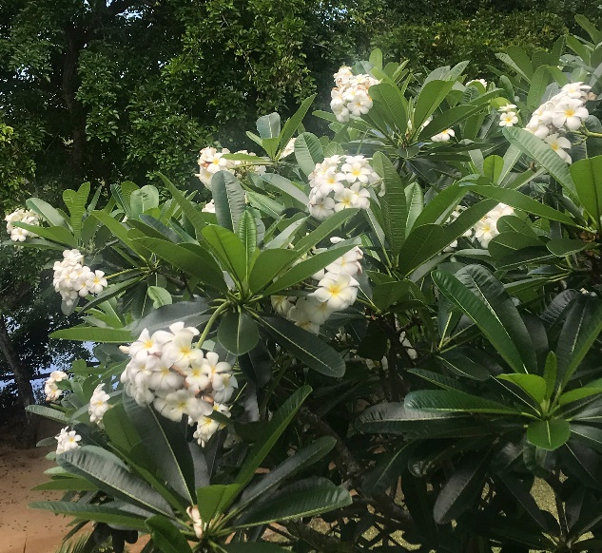

Self-soothing physical activities

9. Hand-holding exercise, (Jin Shin Jyutsu)
With one hand, hold whichever finger/s match your feelings, and take breaths until you feel the strong connection of your pulse in your finger. This can be just for a few breaths or however long feels right for you. Don’t squeeze the finger/s, simply hold them.

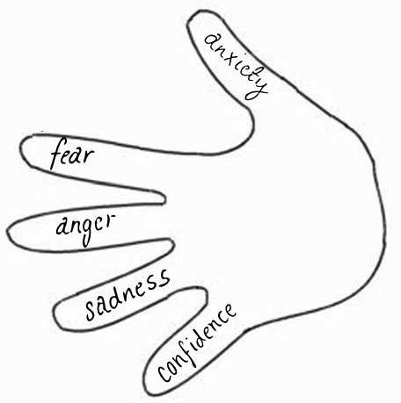

10. Meditation
Guided meditations are available on YouTube for a variety of different times. Trying a few different ones is a good idea to get a feel for the style you like.

11. Yoga practice or a short workout
Again, these are accessible through apps or online. Choose the intensity you feel matches what you need, so a slower one if you feel you need the relaxation and a faster one if you have a lot of pent up energy (e.g. anger, restlessness etc).

12. Hold yourself
The idea is to literally hold yourself so you physically feel contained. This may feel strange at first, but give it a chance, just take a few breaths here and see what works for you.

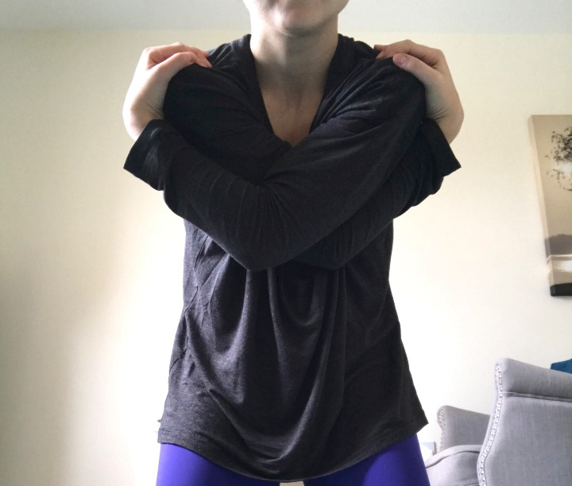

13. Fold forward
So here you’re holding your elbows, leaning forward and almost letting your torso flop. You can also sway side to side gently if you like.

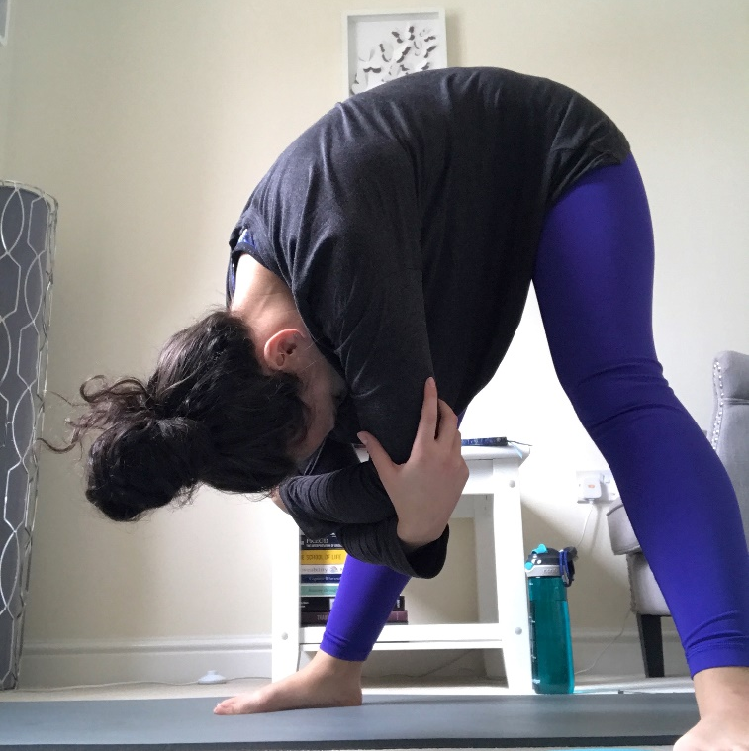

This is featured in yoga which brings us to our next one...

14. Lion breathing
In the stance of folding forward, you breath in through your nose and let out a big lion breath with a wide mouth, almost like you’re trying to breath all the air out. Your stance can be wide like this or feet closer together, whatever feels good.

15. Reclined Bound Angle Yoga Pose
This is another yoga stance that can be particularly peaceful. Hands can be flat on the ground or as featured in this image.

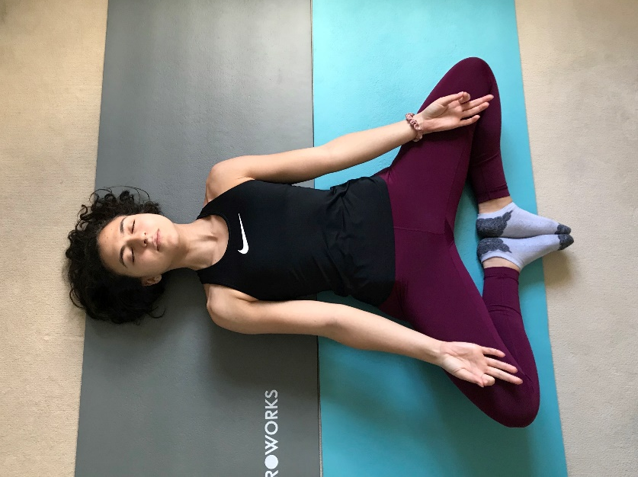
16. Breathing into the area
Breath into the area of your body that you’re feeling tension, and as you exhale try to imagine the breath and tension leaving those areas.

17. Muscle relaxation activity
Courtesy of Every Mind Matters, this activity talks you tensing and releasing muscles in your body in order to feel more relaxed: https://players.brightcove.net/4934638104001/default_default/index.html?videoId=6090022305001

18. Connect with a personal sanctuary
--A particular person you know, who you can connect with via phone, message or online.
--A ‘favourite film’ that gives you a sense of warmth and security.
--A familiar and positive activity that gives you a sense of comfort/ a break.
--A visualised sanctuary: Picture a fond memory, a person, a place, or a time you felt comfortable and calm. This can help to lift our mood, make us feel safe and secure, and can serve to remind us that there is a bigger picture outside of the difficult emotions we are experiencing right now.

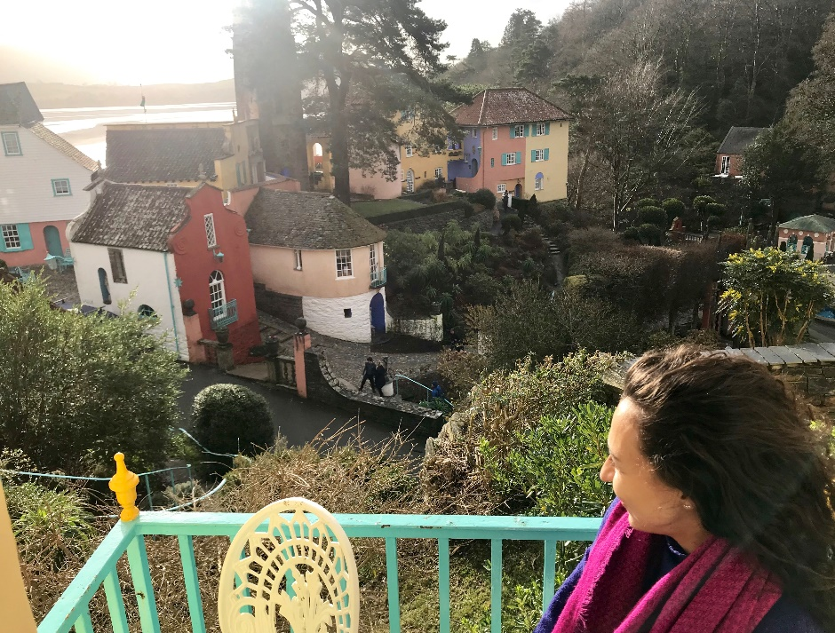

And lastly…

19. Ask for help
We are all human beings and we cannot manage alone, nor should we have to. The final (and possibly most important) tip in handling stress and anxiety is reaching out to others when it all does feel too much. Easier said than done, but the truth is that as individuals, we cannot do it all. Sometimes things are just too much to handle alone, and we need a peer to help us finish a project, a friend to listen to us on the phone, a loved one to let us know that we have their support. We need that reminder that we do not in fact have the whole world resting solely on our shoulders. It can be difficult to delegate, to relinquish control and to trust that others will be there for us if we need support, but it is important to take the risk. Even if someone can’t actively change your circumstance, they might empathise or have had a similar issue in the past; they may have a solution to offer or just a shared experience that alleviates the intensity of what we’re feeling in the moment. It is certainly worth reaching out.

20. Finding balance in life is key. This is even more challenging during this time because of the uncertainty about when normality will return, but it does mean it is even more important to find our own balance. It is so important to incorporate relaxation into our daily lives, so give this a go and see how you get on. Good luck!

