A LEVEL HISTORY:
The Tudors

BRIDGING THE GAP

Contents:
- Introduction to A-level History – The Tudors
- Preparing for Unit 1C The Tudors
- How to take notes at A-level

Section 1: Introduction to History A-level- Unit 1.

L.P. Hartley said:
“The past is a foreign country; they do things differently there.”

You are going to travel to that country. Henry VII won the Battle of Bosworth in 1485. This is considered by historians to be the end of the medieval era and the start of the Tudor and ‘Early Modern’ era of history. Obviously it wasn’t late medieval 31st Dec 1484 and then suddenly fully fledged Tudor 1st Jan 1485, what we consider to be Tudor customs, art, architecture and beliefs developed between 1485 and 1603 when Elizabeth I died.
It is a society which has rigid boundaries – everyone believes G-d has placed them in a level within the social hierarchy or ‘Great chain of being’ as it was known and it was considered undesirable for people to move above that their social station in life. Everyone believes as absolutely as they know the sun will come up every morning, that G-d angels, the devil and demons exist and interact on earth. Superstitious belief supersedes scientific ideas and everyone knows they will be going to heaven or hell via purgatory when they die.
Religion is the absolute centre of everyone’s lives and 90% of all people live a subsistence agricultural lifestyle. There are about 200 families in the ‘nobility’ and the population of London is approximately 50,000 (it is around 11 million today) in 1485.
If you want a job – you need a recommendation – generally a letter from the wealthiest and most powerful person you know. The king dispenses patronage – jobs / money / lands / offices to his most powerful nobles and gets loyalty and taxes in return, and that patronage / those jobs are in turn handed out by their nobles to lesser nobility / gentry and so on - there is no Guardian job vacancies section.
1C is the breadth unit:
Your course will be broken down into these 6 topics for each monarch studied each year.

1C The Tudors: England, 1485–1603 (40%)
This option allows students to study in breadth issues of change, continuity, cause and consequence in this period through the following key questions:
- How effectively did the Tudors restore and develop the powers of the monarchy?
- In what ways and how effectively was England governed during this period?
- How did relations with foreign powers change and how was the succession secured?
- How did English society and economy change and with what effects?
- How far did intellectual and religious ideas change and develop and with what effects?
- How important was the role of key individuals and groups and how were they affected by developments?

Alongside the Tudors you will also:
- Study UNIT 2H – The French Revolution (40%)
- Non-examined element (coursework) which is The Changing role and status of women 1870-1970 – (20%)

Section 2 – ACTIVITIES TO ENHANCE YOUR UNDERSTANDING OF THE TUDORS
You do not have to complete all of these, but select at least three from A-D - from the Make notes / read / listen / watch / virtual visit sections it is best to do as many as you can.
Those in red are the recommended first activities.
Write up anything you find out as a ½ A4 page summary. Choose how you would like to represent your findings – diagram, graphic organiser or bullet point notes.
Which method will summarise the information best? Page 9 gives you ideas about how to make notes.
An interesting overview of the Tudor period can be found in: https://www.amazon.co.uk/Flagship-History-England-1485-1603-level/dp/0003271242/ref=sr_1_5?crid=2E1UYTES3KKJK&dchild=1&keywords=flagship+history&qid=1588621678&sprefix=FLagship+%2Caps%2C155&sr=8-5
This is not our core text book, but it is a frequently referred to text throughout years 12 and 13 and is a valuable resource for extra research into any of the topics below.
There is also a Seneca course for A Level Tudors
https://app.senecalearning.com/classroom/course/554b653d-6c5f-4ace-ac3b-449f5ec988b6
  - Background

- Make notes:
  - The wars of the roses - England before the Tudors: http://www.bbc.co.uk/programmes/p00546sp

- Read:
  - Richard III - pre Henry and Henry VII - 'Daughter of Time' Josephine Tey

- Listen to:
  - The Black Death: (which shapes society as it stands at the start of Henry VII's reign: http://www.bbc.co.uk/programmes/b00bcqt8

  - The study of History:
https://www.bbc.co.uk/programmes/b00gryrx - History of History - Melvyn Bragg and guests discuss how the writing of history has changed over time, from ancient epics to medieval hagiographies and modern deconstructions.
  - Henry VII

- Make notes on:
    - This is an overview of Henry VII’s life and conquest of England
https://www.google.co.uk/url?sa=t&rct=j&q=&esrc=s&source=web&cd=1&cad=rja&uact=8&ved=0ahUKEwiAvIT8pJrcAhVIbRQKHdpPAWEQyCkIMDAA&url=https%3A%2F%2Fwww.youtube.com%2Fwatch%3Fv%3D-5FsriGn300&usg=AOvVaw3EE1DjBTBf-YYbyMO_v_y4
2. Listen to and make notes on:
a) Humanism: http://www.bbc.co.uk/programmes/p00547bk
3. Watch
a) Henry VII in 10 minutes
https://www.youtube.com/watch?v=4TIrgZ6taD4

  - Henry VIII
1. Make Notes
a) An introduction to Henry VIII
https://www.hrp.org.uk/hampton-court-palace/history-and-stories/henry-viii/#gs.5ujrub
b) Thomas Cromwell – Henry’s Chief Minister 1530-1540
https://www.hrp.org.uk/tower-of-london/history-and-stories/thomas-cromwell/#gs.5ur2du
c) Anne Boleyn – lover, wife, Queen.
https://www.hrp.org.uk/tower-of-london/history-and-stories/anne-boleyn/#gs.5ur8pc
2. Read
a) Cromwell: Wolf Hall - Hilary Mantell (a doorstep but worth the effort)
3. Watch
a) Wolf Hall – on Amazon Prime and britbox - Wolf Hall BBC -
http://www.bbc.co.uk/programmes/p02gfy02/products -
Wolf Hall – BBC series https://www.bbc.co.uk/programmes/p02gfy02/episodes/guide
4. Listen to and make notes on:
a) The origins of the European Reformation: http://www.bbc.co.uk/programmes/p005493t
b) The Dissolution of the monasteries under H8: http://www.bbc.co.uk/programmes/b009jtq1
c) Holbein in the Tudor court http://www.bbc.co.uk/programmes/b088fs7z
d) The Field of the Cloth Of Gold: http://www.bbc.co.uk/programmes/b088fs7z
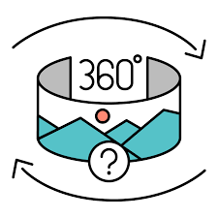
5. Virtual Visit
a) Explore Hampton Court Palace using the hyperlinks in this paragraph: Experience the public dramas and private lives of Henry VIII, his wives and children in the world of the Tudor court. Admire Henry’s Great Hall, the infamous Haunted Gallery and the Tudor kitchens. Discover the spectacular baroque palace built for William III and Mary II and explore the magnificent gardens.

  - Tudor era in general
1. Read
a) A traveller in Time – Alison Utterly (gentle easy-to-read children’s book) set in
the heart of a plot to murder Elizabeth I
b) Life in Henry's England -a lawyer investigates mysteries tied up with politics – CJ Sansom - The Shardlake series – highly recommend – I love these

2. Watch
    - What the Tudors did for us
https://www.imdb.com/title/tt0424743/ - you can find these by searching for the name of the episode and video in google

    - TV - Tudor monastery farm BBC - https://www.bbc.co.uk/programmes/p01k3b96
https://www.dailymotion.com/video/x54lq9o
    - https://www.gresham.ac.uk/series/gresham-500-celebrations/ - choose some aspects of the Tudor period you haven’t looked at yet, e.g. the focus on three Black Tudors, Thomas Gresham’s life (2019 y13s all did economics as well and loved Gresham and John Guy is the premier Tudor Historian today), The Tudor Court.
    - Documentary List of David Starkey’s Tudor documentaries
https://www.youtube.com/watch?v=1eaMix9x4HE&list=PLYOaFvSd0bB2p3vzLnJSETk-jypqfhUpY

3. Make Notes
a) Henry VIII’s children – an introduction
https://www.hrp.org.uk/hampton-court-palace/history-and-stories/henry-viiis-children/#gs.5ukeut
4. Virtual Visit
- Explore the Historic Royal palaces through their 360 virtual tours AND their videos highlighting key parts of their collections – explore the palaces built by Henry VIII
https://www.hrp.org.uk/discover-the-palaces/#gs.5ull1s
- Take a virtual tour of the National Portrait Gallery’s Tudor Gallery – Copy and paste the picture into a new document and write one sentence about each portrait – who it is / why they had their portrait painted / what they did / why they were important
https://www.npg.org.uk/collections/search/portrait-list.php?search=ap&subj=370;Tudors+and+Elizabethans+tour

- Explore how Elizabeth I’s image – a key propaganda tool changed throughout her reign
https://www.npg.org.uk/research/programmes/making-art-in-tudor-britain/case-studies/the-queens-likeness-portraits-of-elizabeth-i
5. Listen
a) The Tudor State - how was government shaped by the Tudor Dynasty? http://www.bbc.co.uk/programmes/p00546xd
b) Listen to these podcasts from the Historic Royal Palaces - the Tower of London- April 8th / 15th / 22nd / 29th / March 4th / Feb 26th / All of October’s
Apple podcast link:
https://podcasts.apple.com/gb/podcast/historic-royal-palaces-podcast/id1065848261
Spotify podcast link:
https://open.spotify.com/show/64ORUgrG2NE7UYxpsZ6HyC

Useful skills for further education
- The Open University have a number of free online course. https://www.open.edu/openlearn/free-courses/full-catalogue
You can filter by selecting History and the Arts.
Here are a few to get you started:
- Open University: Extending your thinking skills https://www.open.edu/openlearn/education/extending-and-developing-your-thinking-skills/content-section-0?intro=1
- Open University : What is good writing?
https://www.open.edu/openlearn/history-the-arts/culture/literature-and-creative-writing/what-good-writing/content-section-0?intro=1
- Open University: History of Reading: An introduction to reading in the past https://www.open.edu/openlearn/history-the-arts/culture/literature-and-creative-writing/history-reading-introduction-reading-the-past/content-section-0?active-tab=description-tab

- The National Archives:
  - Investigate original documents from the reign of Elizabeth I http://www.nationalarchives.gov.uk/education/resources/elizabeth-monarchy/
  - Focus on film as an information source http://www.nationalarchives.gov.uk/education/focuson/film/
  - Paleography: Take a tutorial in learning to read handwriting from documents 1500-1800 http://www.nationalarchives.gov.uk/education/resources/palaeography/
- Articles
  - Synoptic essays https://www.history.org.uk/student/categories/916/resource/3210/what-is-a-synoptic-essay-and-how-do-i-write-one
  - Explore Aeon magazine’s articles – here’s one to get you started - How to reduce digital distractions, advice from medieval monks https://aeon.co/ideas/how-to-reduce-digital-distractions-advice-from-medieval-monks
If you think you might want to study a Humanities subject at Uni – then try https://www.univ.ox.ac.uk/applying-to-univ/resource-hub/?category=humanities

Section 3 - Taking notes at A-level
During classes and for home learning you will be expected to take notes on a broad range of topics and case studies, therefore it is important that you arrange and structure these notes in a way that is both informative and easy to revise from when required. The more organised you are with your note taking the easier your revision will be.
To help you with note taking at A-level below are some different note taking and revision strategies that you should be familiarising yourselves with. Not every format will work for you but it is important that you establish good practice. Notes are not about writing down everything they are about recording the key information As you go through the resources above try some of the different note taking strategies below:

1. The outline method:
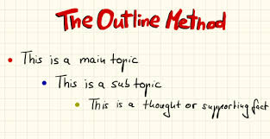
One of the best and most popular methods, it lets you organise notes in a structured form and break up different topics and their subtopics. Main topics go on the far left and add subtopics below using indents.
Pros:
- Highlights points in a logical way
- Reduces reviewing and editing time
- Gives a clear structure.
Cons:
- Doesn’t work well if the lesson or resource jumps between topics.
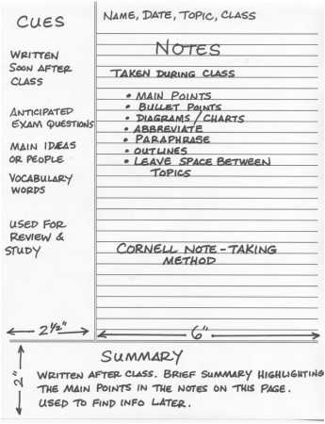
2. The Cornell Note:
http://lsc.cornell.edu/study-skills/cornell-note-taking-system/
One you may be familiar with from GCSE. A very structured form of note taking with a clear page layout, all the main notes from class go in the main note taking section, the small left hand column is for main topics or questions, and the section at the bottom allows you to summarise your learning.
Pros:
- A quick way to organise and review notes
- Very systematic
- Cuts down reviewing time
Cons:
- Requires preparation beforehand
- Needs time for reviewing and summarising after the lesson.

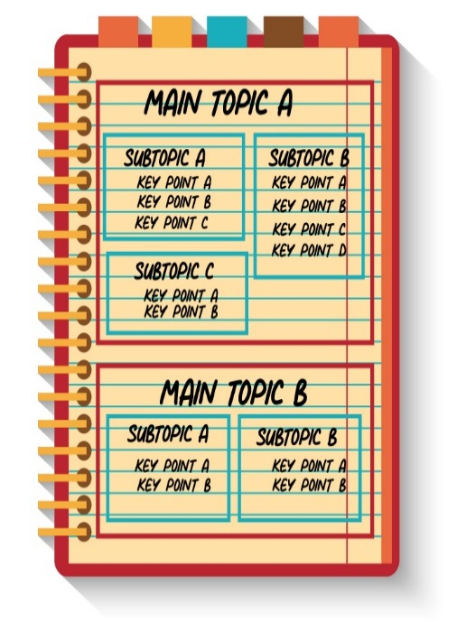
3. The Boxing Method:
A less common method but becoming more popular. A dedicated box is assigned for each section of notes, with smaller boxes used for each sub section. Best used when doing digital notes but can still be used for hand written work or when reviewing notes from a lesson.
Pros:
- Segregates and organises information
- Allows you to focus on one box at a time when revising
Cons:
- Not east to do during a live lesson
- Doesn’t work well if no overall topics can be assigned to groups.

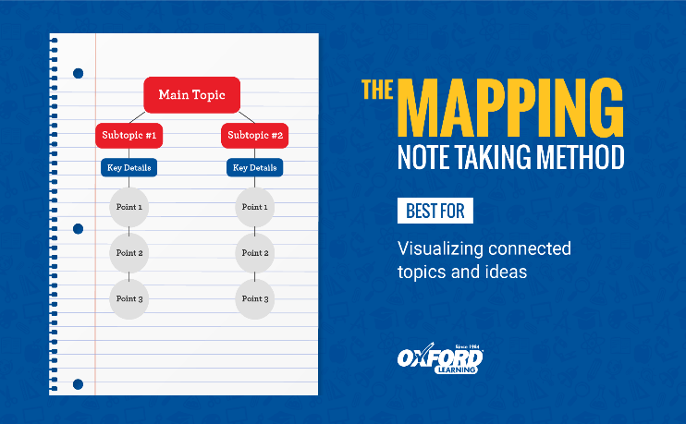
4.The Mapping Method:
Mind mapping is one of the most common forms of note taking, and is best used when there is a large amount of content around a topic, for instance tectonics has a large number of volcanic and seismic case studies. Mind mapping is also useful to show the relationships and links between different sub topics.
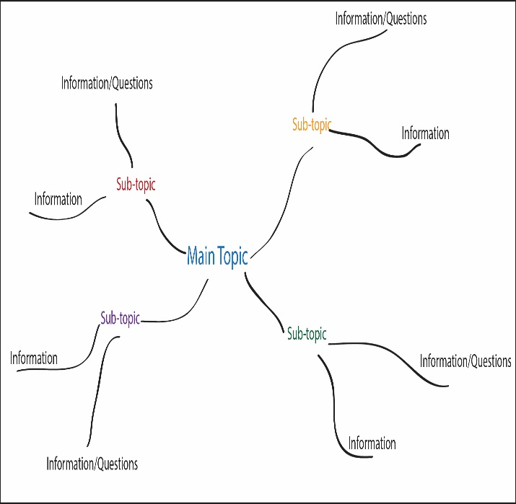
There are two types of mind mapping you can use, a traditional mind map (spider diagram) or a flow line map.
A traditional mind map is excellent for breaking down large case studies or key ideas, whilst a flow line map is an excellent visual way of outlining geographic processes.
Pros:
- Visually appealing
- Detailed information in a concise form
- Easy editing of notes
Cons:
- Can run out of space if notes are too detailed
- Can be time consuming to create.

There is no definitive way to take notes and you will naturally fall into a structure that is natural for you during lessons.

