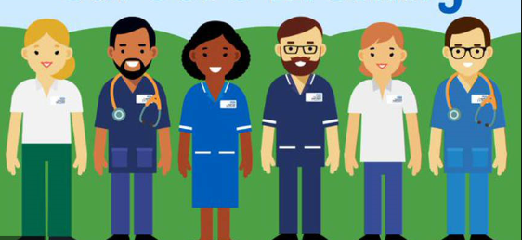

Bridging task for health and social care
When you embark on a care in health and social care you have to be able to ensure that you can communicate well, this is a vital quality that all people working in this industry should have. You should think about the qualities that are needed for a person that works within this industry.

Can you think of the most important qualities?
1.
2.
3.
Communication is important
How many different types of communication can you think of?

Are they different or do they have things in common?

What is communication?
Write your own definition.
_________________________________________________________________________________________________________________________________________________________________________________________________________________________________

In your opinion, what does “effective” mean?
______________________________________________________________________________________________________________________________________________________

Task:
What is it we need to remember in order to communicate effectively with others?
In the space below list the factors that influence effective communication:
•
•
•
•
•
•

Now select 3 factors you have listed above and give an example for each one:
1.
2.
3.
Barriers
Are barrier is something that stops communications from happening effectively
List the barriers to effective communication e.g. to noisy

What is the difference is between closed and open questions?
Why do you think it’s important to use both?
Can you put these in to categories of open and closed questions?
Open | Closed

Do you like Cats, Have you been on holiday, where did you go on holiday, how would you like to be remembered, what do you think should happen at the end of the story, what specifically happened today, was it your fault.

What does context mean? Why are context different depending on your care.
Think about the differences between IJE and JE lessons- how are they different?
Can you now relate this to someone having care in a hospital and then them going home- how would their care change and how would their relationship with the people around them change.
Think about their families, doctors or professionals in both places- is there a difference? If so how is it different? Write down how the two scenarios are different.
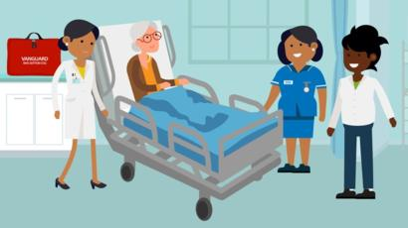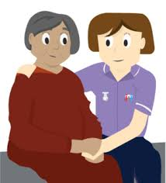

Theories for communication

There are 3 theories you need to understand in Health and social care unit 1- have a look at these websites and videos to help you understand communication.

Argyles communication theory- https://study.com/academy/lesson/communication-cycle-definition-stages.html
Tuckmans theory - http://www.mindtools.com/pages/article/newLDR_86.htm
SOLER- https://www.myrtwellbeing.org.uk/communication/active-listening-skills-using-the-soler-method/401.article, https://www.youtube.com/watch?v=BW82k7lwI_U
Understand what a Person centred approach to care- http://personcentredcare.health.org.uk/sites/default/files/resources/person-centred_care_made_simple_1.pdf, http://www.bapca.org.uk/about/what-is-it.html, http://www.scie.org.uk/publications/guides/guide08/person.asp

Useful website
https://www.youtube.com/watch?v=S7CN9Trw43w
https://www.skillsforcare.org.uk/Topics/Mental-Health/Mental-health.aspx
http://www.nhs.uk/conditions/social-care-and-support-guide/pages/care-homes. asp
http://www.scie.org.uk/assets/elearning/communicationskills/cs02/resource/ index.html

