A LEVEL GEOGRAPHY: BRIDGING THE GAP

Contents:
- Introduction to A-level Geography
- Preparing for Human Geography in year 12
- Preparing for Physical Geography in year 12
- How to take notes at A-level
- Wider reading resources.
- Preparing to study A-level Geography.

Section 1: Introduction to Geography A-level.

Geography A-level is a in depth study of the world we live in, over the two year course you will study 8 different topics that will familiarise you with the diverse range of economic, political, social, cultural, and environmental processes that interact to shape our world. Your course will be broken down into 4 topics studied each year alongside an independent geographic investigation on a topic of your choosing worth 20% of your final grade. At the end of the two year course you will sit three exams.

- Paper 1: Physical landscapes and processes
- Paper 2: Human landscapes and processes
- Paper 3: Synoptic paper on global issues combining the human and physical sides of the course.

Your topics for year 12 are highlighted below, over the following pages are a range of resources and activities that will introduce you to the key themes you will be studying and will start preparing you to study A-level Geography.

Year 12 Geography topics:
Topic 3: Globalisation  Globalisation and global interdependence continue to accelerate, resulting in changing opportunities for businesses and people. Inequalities are caused within and between countries as shifts in patterns of wealth occur. Cultural impacts on the identity of communities increase as flows of ideas, people and goods take place | Topic 1: Tectonic Hazards:  Tectonic hazards – earthquakes, volcanic eruptions and secondary hazards such as tsunamis represent a significant risk in some parts of the world. An in-depth understanding of the causes of tectonic hazards is key to both increasing the degree to which hazards can be managed, and putting in place successful responses that can mitigate social and economic impacts and allow humans to adapt to hazard occurrence.
Topic 4B: Regeneration  Urban and rural regeneration programmes involving a range of players involve both place making (regeneration) and place marketing (rebranding). Regeneration programmes impact variably on people both in terms of their lived experience of change and their perception and attachment to places. The relative success of regeneration and rebranding for individuals and groups depends on the extent to which lived experience, perceptions, and attachments to places are changed. | Topic 2B: Changing Coastal Landscapes  Coastal landscapes develop due to the interaction of winds, waves and currents, as well as through the contribution of both terrestrial and offshore sources of sediment. These flows of energy and variations in sediment budgets interact with the prevailing geological and lithological characteristics of the coast to operate as coastal systems and produce distinctive coastal landscapes. These landscapes are increasingly threatened from physical processes and human activities, and there is a need for holistic and sustainable management of these areas

Section 2: Human Geography Year 12:

You will study two units: Globalisation and Regeneration

Human geography is the branch of geography that studies the interrelationship between people, place and their environment. To be a successful human geographer it is therefore critical that you have a thorough understanding of the broad range of economic, social, cultural, and political processes that influence how we function as both local and global communities.

In order to fully understand the complex interaction of these global processes and their rapid development it is therefore important that you have an up to date knowledge of the economic, political and social developments happening around the world. Below for both regeneration and globalisation are a range of articles, podcasts, and video clips that will help to introduce the topics you will be undertaking this year and allow you to start familiarising yourself with different sources of information you will be able to use throughout you’re A – level study.

As you go through the different articles I would recommend this as an opportunity to practice different forms of note taking, later on in this booklet you will find a guide on how to take notes at A-level, we recommend you practice didn’t forms of note taking and revision to see what works best for you
.
Topic 3: Globalisation – resources.
Listen:
- The Guardian - Globalisation: the rise and fall of an idea that swept the world: https://www.theguardian.com/news/audio/2017/jul/31/globalisation-the-rise-and-fall-of-an-idea-that-swept-the-world-podcast
- BBC – Globalisation Winners and Loser: https://www.bbc.co.uk/sounds/play/p057b865
- The Economist – Is this the era of slowbalisation: https://www.economist.com/podcasts/2019/01/24/is-this-the-era-of-slowbalisation

Read:
- National Geographic - International organisations: https://www.nationalgeographic.org/encyclopedia/international-organization/
- The Financial Times: Globalisation and Covid19: https://www.ft.com/content/49a7c20a-72a2-11ea-95fe-fcd274e920ca
- Dartmouth College Human geography - https://researchguides.dartmouth.edu/human_geography/main

Watch:
- Ted Talk - The Myth of globalisation: https://www.youtube.com/watch?v=xUYNB4a8d2U
- Globalisation Crash course 1 and 2: https://www.youtube.com/watch?v=5SnR-e0S6Ic, https://www.youtube.com/watch?v=s_iwrt7D5OA

Globalisation Glossary: As you progress through the different links above you will find some terms you are familiar with and some key phrases you may not be sure on, below are some of the key phrases, organisations and concepts linked to globalisation that will help you access the globalisation course.
Key term | Definition
BRICS group
Commodities
Cultural globalisation
Economic globalisation
Emerging economies
EU
Foreign Direct Investment
Globalisation
Infrastructure
Interdependency /interdependence
International Monetary Fund (IMF)
Nationalist
Natural resources
Non-Governmental Organisations (NGOs)
Political globalisation
Sustainability

Topic 4B: Regeneration:
Watch:
- TED x – Regeneration through culture: https://www.youtube.com/watch?v=4o_Kp49zuSM
- TED – Regenerating areas with Cultural Heritage: https://www.youtube.com/watch?v=xkjEzYg1PwU

Listen:
- The regeneration podcast - The Regeneration game: https://www.citymetric.com/skylines/podcast-regeneration-game-4703
- The real cost of Regeneration - https://www.theguardian.com/news/audio/2017/aug/04/the-real-cost-of-regeneration-podcast

Read:
- The Guardian: Regeneration – The issue explained: https://www.theguardian.com/society/2001/mar/19/regeneration.urbanregeneration1
- The independent: Regeneration is not a dirty word: https://www.independent.co.uk/voices/regeneration-housing-gentrification-crime-housing-estates-community-a7637771.html

Regeneration Glossary: Below are some of the common geographic terms you will need to be able to apply to our regeneration topic, The most successful A-level geographers will be able to use a wide range of complex geographic language so it is important that you familiarise yourselves with as many of these phrases as possible.
Key term | Definition
Regeneration
Rebranding
Primary sector
Secondary sector
Tertiary sector
Quaternary sector
Gentrification
Positive multiplier effect
Spiral of decline
De-industrialisation
Cost-benefit analysis

PHYSICAL GEOGRAPHY IN Y12
You will study 2 units: TECTONIC HAZARDS and COASTS.
As an A-level Geographer, you will need to stay up to date with Geography in The News. The Radio 4 programme – “Costing The Earth” – is excellent, especially for environmental matters. You should listen to it regularly, even if it doesn’t directly link to the content in the EDEXCEL specification.
From time to time though, they will run a show that links directly to what you are studying. Below are the most relevant episodes (plus one from a different Radio 4 show called “My Name Is”)
For now, have a listen to them (URLs are included here) and take some notes. I recommend “Cornell Notes” as an effective style. Remember, this sort of wider reading (or listening) will give you understanding of key concepts and issues, as well as some excellent extra case studies. Perhaps you might organise your notes under these categories…
Topic 1: Tectonic Hazards:
Watch:
- Gresham College Lectures: https://www.gresham.ac.uk/series/volcanoes/
- Vex: Why there’s a ring of natural disasters around the Pacific: https://www.youtube.com/watch?v=DrwYtGf40hA
Listen:
- Natural Disasters Podcast: https://www.parcast.com/naturaldisasters (Available through Spotify.)
- BBC - Plate tectonics: https://www.bbc.co.uk/programmes/b008q0sp
- The Royal Geographic society: https://www.rgs.org/schools/teaching-resources/plate-tectonics-and-earthquake-prediction/

Read:
- Live Science: https://www.livescience.com/37706-what-is-plate-tectonics.html
- The Geological Society: https://www.geolsoc.org.uk/Plate-Tectonics/Chap2-What-is-a-Plate
Key term | Definition
Benioff zone

Collision margin
Conservative margin (transform)
Convection
Convergent margin
Disaster
Divergent margin
Earthquake
Governance
Hazard
Hazard management
Inequality
Magnitude
Plate tectonics
Seismic hazards
Socio-economic
Subduction
Volcanic hazards
Vulnerability

Topic 2: Coastal Landscapes
Watch:
- National geographic: Global flooding over the next 100 years: https://www.youtube.com/watch?v=WArROU2Axug
- How the coast works: https://www.youtube.com/watch?v=3RauOeHkQk4

Listen:
- Carolyn: Living On A Cliff Edge My Name Is... www.bbc.co.uk/programmes/b08mb1g0
- Carolyn's fighting to save her home from falling into the sea. https://www.bbc.co.uk/programmes/m00051gj
Read:
- National geographic: Introduction to coastal landscapes https://www.nationalgeographic.org/encyclopedia/coast/
- Climate Central: https://www.climatecentral.org/news/report-flooded-future-global-vulnerability-to-sea-level-rise-worse-than-previously-understood

Key term | Definition
Abrasion
Attrition
Beach
Biological weathering
Chemical weathering
Climate change
Corrosion
Erosion
Freeze-thaw weathering
Geology
Geomorphology
Hydraulic Action
Joints
Lithology
Mass movement
Subaerial processes
Weathering

Taking notes at A-level
During classes and for homelearning you will be expected to take notes on a broad range of topics and case studies, therefore it is important that you arrange and structure these notes in a way that is both informative and easy to revise from when required. The more organised you are with your note taking the easier your revision will be.
To help you with note taking at A-level below are some different note taking and revision strategies that you should be familiarising yourselves with. Not every format will work for you but it is important that you establish good practice. Notes are not about writing down everything they are about recording the key information As you go through the resources above try some of the different note taking strategies below:
1. The outline method:
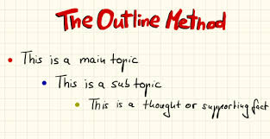
One of the best and most popular methods, it lets you organise notes in a structured form and break up different topics and their subtopics. Main topics go on the far left and add subtopics below using indents.
Pros:
- Highlights points in a logical way
- Reduces reviewing and editing time
- Gives a clear structure.
Cons:
- Doesn’t work well if the lesson or resource jumps between topics.
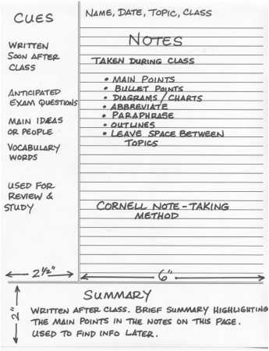
2. The Cornell Note:
One you may be familiar with from GCSE. A very structured form of note taking with a clear page layout, all the main notes from class go in the main note taking section, the small left hand column is for main topics or questions, and the section at the bottom allows you to summarise your learning.
Pros:
- A quick way to organise and review notes
- Very systematic
- Cuts down reviewing time
Cons:
- Requires preparation beforehand
- Needs time for reviewing and summarising after the lesson.
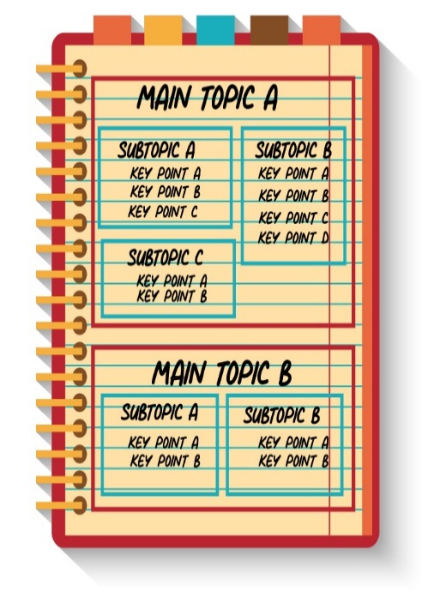
3. The Boxing Method:
A less common method but becoming more popular. A dedicated box is assigned for each section of notes, with smaller boxes used for each sub section. Best used when doing digital notes but can still be used for hand written work or when reviewing notes from a lesson.
Pros:
- Segregates and organises information
- Allows you to focus on one box at a time when revising
Cons:
- Not east to do during a live lesson
- Doesn’t work well if no overall topics can be assigned to groups.

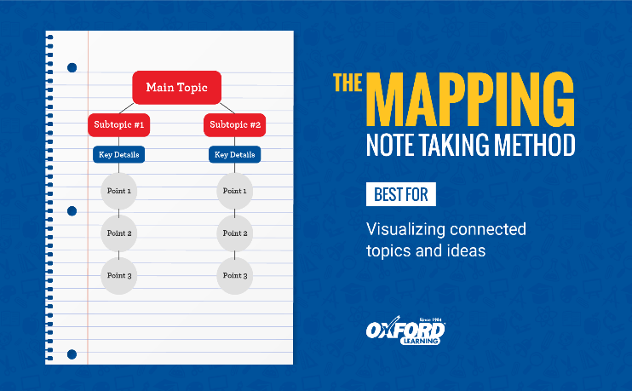
4.The Mapping Method:
Mind mapping is one of the most common forms of note taking, and is best used when there is a large amount of content around a topic, for instance tectonics has a large number of volcanic and seismic case studies. Mind mapping is also useful to show the relationships and links between different sub topics.
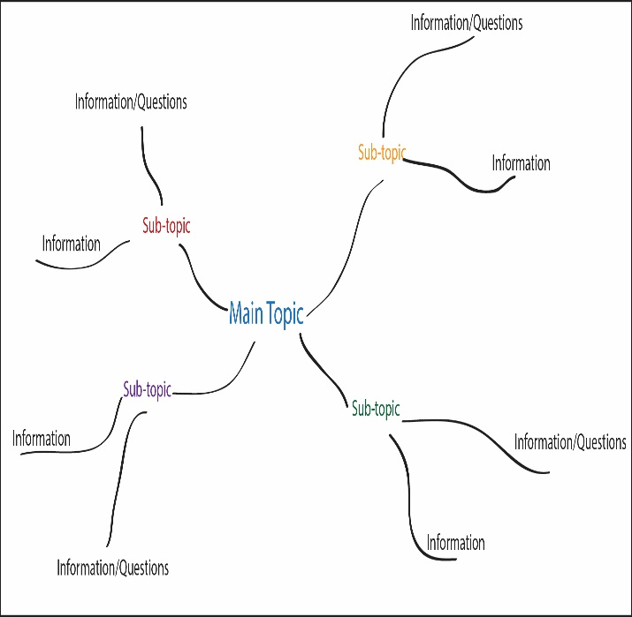
There are two types of mind mapping you can use, a traditional mind map (spider diagram) or a flow line map.
A traditional mind map is excellent for breaking down large case studies or key ideas, whilst a flow line map is an excellent visual way of outlining geographic processes.
Pros:
- Visually appealing
- Detailed information in a concise form
- Easy editing of notes
Cons:
- Can run out of space if notes are too detailed
- Can be time consuming to create.

There is no definitive way to take notes and you will naturally fall into a structure that is natural for you during lessons.

Wider Reading:
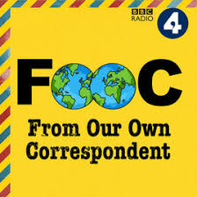
Useful Podcasts: All available through Apple music and Spotify.
- From our own Correspondent: BBC
BBC News correspondents cover a wide range of geographical themes that will do more for your understanding of global news and how this links into the curriculum.
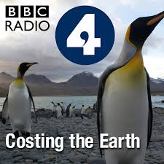
- Costing the Earth: BBC radio 4
BBC news podcast Fresh ideas from the sharpest minds working toward a cleaner, greener planet
- This American Life
- Ted Talks Daily
- Global News Podcast BBC
- Human Geo in 20 minutes
- Economist Radio

Magazines/ Newspapers:
- The Economist
- National geographic/ Geography Review
- The Guardian
- The Geographer: https://www.rsgs.org/the-geographer
- Geographical Free Ebooks: https://geographical.co.uk/magazine/newsletters

Useful websites for revision:
- http://qualifications.pearson.com/en/qualifications/edexcel-a-levels/geography-2016.html
- https://geographyrevisionalevel.weebly.com/
- http://www.coolgeography.co.uk/advanced/
- http://www.geographyalltheway.com/
- http://www.s-cool.co.uk/a-level
- https://geographyas.info/
- http://www.hoddereducation.co.uk/myrevisionnotesdownloads

