The following tasks will give you a taste of topics studied at Economics at A level and some useful background knowledge. To be successful you are expected to know what is going on in the real world, so the best way to start is to read news websites regularly. (Use the business and economy tabs).
If you have further questions or constructive comments, please email me on lkritz@jcoss.barnet.sch.uk.

- Macroeconomics research task
- Research people of interest in Economics
- Consider the effects of the sugar tax

Task 1 – The UK Economy

Four key indicators of how well the economy is performing are:
- Unemployment rate
- Inflation rate
- Balance of Payments/Current account balance
- Rate of change of GDP

Complete the table below. You may find the BBC website useful for this task. Write notes in the boxes but do not cut and paste chunks of text – use your own words. This is the basis of all Y12 work.
 | Inflation | Unemployment | Current account | Change in GDP
Explain what this is and why it is important for the economy.
How is it measured?
What is the current rate?

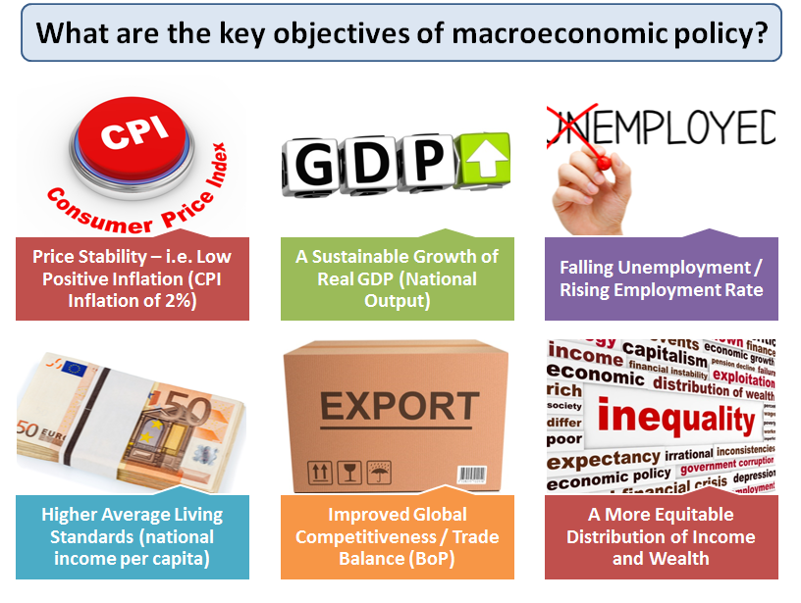
Task 2 – Notable figures in Economics

- Find out the name of these job-holders and a little about the organisations they lead:
- The Chancellor of the Exchequer
- The Governor of the Bank of England
- Secretary of State for Business, Energy and industrial Strategy
- Chair and Managing Director of the IMF

- Research a notable figure in Economics (from the picture below) and give around a page of detail in the spaces below
My name:

I chose to research

I chose him/her because

I found out that s/he (describe his/her notable contribution)

I would like to find out more/I have questions about ……..

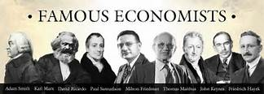

Task 3 – Taxing unhealthy foods 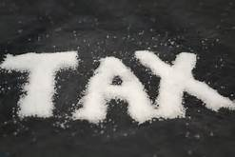

In the budget speech in March 2016 George Osborne, the then Chancellor of the Exchequer, announced the introduction of a tax on soft drinks. There will be two bands - one for drinks with total sugar content above 8g per 100 millilitres which would hit drinks such as Coca-Cola and Pepsi, Lucozade Energy and Irn-Bru. The tax charged will is between 18p and 24p per litre.
Now England’s Chief Medical Officer is proposing a similar tax on ‘unhealthy foods’ in an attempt to persuade parents to choose more fruit and vegetables.
Research the arguments both for and against the UK introducing this tax and decide whether you think it is a good idea. Summarise the arguments on a single sided (A3 or A4), putting both sides of the argument and justifying your own view. Do not copy and paste large chunks of text, you need to pick out the key arguments and put them in your own words. Illustrate your argument with relevant graphics and figures. These could show:
- how much consumption of sugary drinks has changed in recent years,
- how much the price of unhealthy drinks has changed over the years
- evidence to suggest there is a need for action of this kind,
- how much money would be raised from the tax or
- what impact it might have on the consumption of unhealthy foods

The following sources of information might help:
http://www.bbc.co.uk/news/health-38212608
https://www.youtube.com/watch?v=y8q48JKHTgQ
http://www.theguardian.com/politics/2016/mar/19/sugar-tax-all-fizz-or-weighty-blow-obesity

