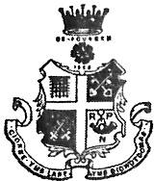
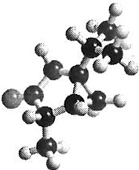
Ripon Grammar School

Chemistry Department L6 Induction Work

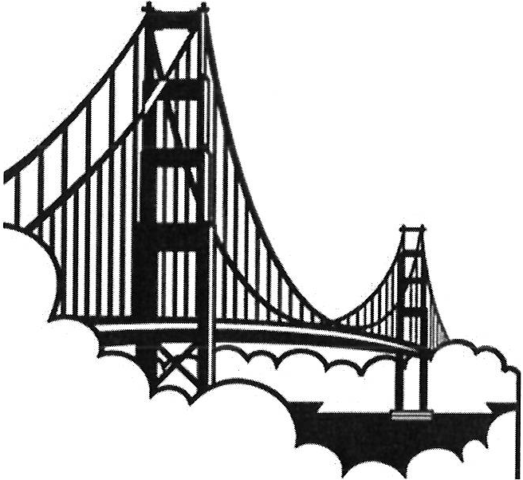
Bridging the gap between GCSE and Advanced level

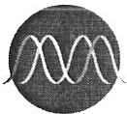
Engineering
Summer 2016

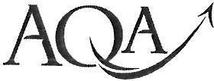
1

The Periodic Table of the Elements

1 2 3 4 5 6 7 0
. - ,
(1) | (2) |  | Key |  |  |  | 1.0  H  hydrogen  1 |  |  |  |  | (13) | (14) | (15) | (16) | (17) | 4.0
 |  |  |  |  |  |  |  |  |  |  |  |  |  |  |  |  | He
 |  |  |  |  |  |  |  |  |  |  |  |  |  |  |  |  | helium
 |  |  |  |  |  |  |  |  |  |  |  |  |  |  |  |  | 2
6.9 | 9.0 | (3) | relative atomic mass  symbol  name  atomic (proton) number  (4) (5) (6) |  |  | (7) | (8) | (9) | (10) | (11) | (12) | 10.8 | 12.0 | 14.0 | 16.0 | 19.0 | 20.2
Li  lithium | Be  beryllium
 |  |  |  |  |  |  |  |  |  |  |  | B  boron | C  carbon | N  nitrogen | 0  oxygen | F  fluorine | Ne  neon
3 | 4 |  |  |  |  |  |  |  |  |  |  | 5 | 6 | 7 | 8 | 9 | 10
23.0  Na  sod ium  11 | 24.3  Mg  m agnes[um  12 |  |  |  |  |  |  |  |  |  |  | 27.0  Al  aluminium  13 | 28.1  Si  silicon  14 | 31.0  p  phosphorus  15 | 32.1  s  sulfur  16 | 35.5  Cl  chlorine  17 | 39.9  Ar  argon  18
39.1 | 40.1 | 45.0 | 47.9 | 50.9 | 52.0 | 54.9 | 55.8 | 58.9 | 58.7 | 63.5 | 65.4 | 69.7 | 72.6 | 74.9 | 79.0 | 79.9 | 83.8
K  po tassium | Ca | Sc | Ti | V | Cr | Mn | Fe | Co |  | Cu | Zn | Ga | Ge | As | Se | Br | Kr
 |  |  |  |  |  |  |  |  | Ni
 | calcium | scandium | titanium | vanadium | chromium | manganese | iron | cobalt | nickel | copper |  |  |  |  |  | bromine | krypton
 |  |  |  |  |  |  |  |  |  |  | zinc | gallium | germanium | arsenic | selenium
19 | 20 | 21 | 22 | 23 | 24 | 25 | 26 | 27 | 28 | 29 | 30 | 31 | 32 | 33 | 34 | 35 | 36
85.5  Rb | 87.6  Sr | 88.9  y | 91.2  Zr | 92.9  Nb | 96.0  Mo |  | 101.1  Ru  ruthenium  44 | 102.9  Rh | 106.4  Pd | 107.9  Ag | 112.4  Cd | 114.8  In | 118.7  Sn | 121.8  Sb | 127.6  Te | 126.9  I | 131.3  Xe  xenon  54
rubidi um | strontium | yttrium | zirconium | niobium | molybdenum | technetium |  | rhodium | palladium | silver | cadmium | indium | tin | antimony | tellurium | iodine
37 | 38 | 39 | 40 | 41 | 42 | 43 |  | 45 | 46 | 4 7 | 48 | 49 | 50 | 51 | 52 | 53
132.9  Cs  caesium  55 | 137.3  Ba  barium  56 | 138.9  La *  lanthanum  57 | 178.5  Hf  hafnium  72 | 180.9  Ta  tantalum  73 | 18w3.8  tungsten  74 | 186.2  Re  rhenium  75 | 190,2  Os  osmium  7ci | 192.2  Ir  iridium  77 | 195.1  Pt  platinum  78 | 197.0  Au  gold  79 | 200.6  Hg  mercury  80 | 204.4  Tl  thallium  81 | 207.2  Pb  lead  82 | 209.0  Bi  bismuth  83 | [209]  Po  polonium  84 | [210)  At  astatine  85 | [222]  Rn  radon  86
[223)  Fr  francium  87 | [226)  Ra  radium  88 | [227)  Ac t  actinium  89 | [267)  Rf  rutherfordrJm  104 | (268]  Db  dubnium  105 | (271)  Sg  seaborgium  106 | [272]  Bh  bohrium  107 | [270]  Hs  hassium  108 | [276]  Mt  meitnerium  109 | [281]  Os  dcrmstl1tull  110 | [280]  Rg  roentgenii.m  111 | Elem ents w ith atom ic numbe rs 112 -116 have been reported but not fully authent icated

- 58 - 71 Lanthanides
140.1  Ce  cerium  58 | 140.9  Pr  praseodyrrium  59 | 144.2  Nd  neodymium  60 | (145]  Pm  promett,ium  61, | 150.4  Sm  samarium  62 | 152.0  Eu  europium  63 | 157.3  Gd  gadolni ium  64 | 158.9  Tb  terbium  65 | 162.5  Dy  dysprosium  66 | 164.9  Ho  hOlmium  67 | 167.3  Er  erbium  68 | 168.9  Tm  thulium  69 | 173.1  Yb  ytterbium  70 | 175.0  Lu  lutetium  71
232.0  Th | 231.0  Pa | 238.0  u | [237)  Np | [244]  Pu | [243]  Am | (247]  Cm | [247}  Bk | [251]  Cf | [252)  Es | [257]  Fm | [258)  Md | (259)  No | {262]  Lr
thorium | protactinium | uranium | neptunium | plutonium | americium | curium | berkelium | californium | einsteinium | fermium | melldelevium | no beliu m | lawrencium
90 | 91 | 92 | 93; | 94 | 95 | 96 | 97 | 98 | 99 | 100 | 101 | 102 | 103

t 90 - 103 Actinides

N

Advanced level Chemistry is a demanding and exciting course. In order to be prepared for your start in September a number of areas from GCSE Chemistry are needed to be known and/or understood t horo ughly. To help you make the transition as smoothly as possible we have put together this series of exercises. When you start in September you will be expected to have completed the exercises within this booklet and know the material within. There will be a test on this material approximately one week into the course. It is by no means ALL you need to know but the very foundations of the exciting journey you are about to start. If you have difficulties or confusions there are a number of suggested online resources you could t ry. There will be opportunities to discuss concerns with staff at the beginning of the year but you should have made significant headway independent ly.

This booklet contains some undetailed notes to act as a reminder. If you struggle with a particular area you should investigate the suggested support resources, your GCSE notes and your local library. There are exercises for you to complete, the answers are at the end.
Section A is on chemistry aspects, section B on mathematical aspects. These are the foundations and not the entire required skill set.
Contents

Topic

Formula literacy
Page
5-7
Additional help sources (linked)
You tube writing formulae

Identifying Structure types

Identifying acids, bases and
salts Common reaction types Balancing equations Rearranging equations
Significant figures Standard form
Indices Graph skills
Scales
8

9-10

11-12

13-14

15

16-17

17-19

19

20-21

22
You tube How To Speak Chemistrian: Crash Course Chemistry #11

You tube Fuse school Balancing eqns Pt 1 You tube Fuse school Balancing eqns Pt 2 You tube GCSE Physics support!

Unit Conversion & Significant Figures : Crash Course Chemistry #2
Writing a number in standard form

Useful resources:
- Use your GCSE not es.
- There are a few selected video clips listed above in the contents t abl e. There is a great wealth of other information on the internet (and some of it is useful and/or correct). These resources have been specifi cally selected for your viewing pleasure!
- Essential M at hs Skills for A-Level Chemistry by CGP ISBN 978 4 78294 472 0

3

WHERE AM I?
Use these warm up questions to evaluate where you are now and what you can do already. If you get something right through guessing, you do not necessarily know it!
Check with the answers at the end of the booklet to assess which topics you need to develop your understanding of.
The expectation is that youcan do this with ease.
It is your responsibility to address any issues and seek support where necessary.
Magnesium reacts with nitric acid to produce a salt and a gas. The salt is used in chemical agriculture and is produced naturally when guano reacts with magnesium containing rocks.
  - Write a balanced symbol equation reaction for the reaction.

  - Give the structure types of the two products formed.

  - The experiment produced 7.00g of the salt. This was 85.0% of the expected yield. Assuming the magnesium was the limiting factor what mass of magnesium was used in the initial reaction?

  - 1.30dm³ of gas was produced in 7.00 minutes. What is the rate of gas production in cm³s-¹?

  - Name a suitable base which would produce the same salt as the original reaction with nitric acid. Write a balanced symbol equation for this reaction.

  - At 298K the solubi lity of the salt is 125g/100ml in water. What is the mass of the saturated solution at 25°C if the volume of water used is 1.85 x 1-0 ¹dm³?

{ANSWERS ARE ON THE LAST PAGE}

4

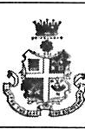
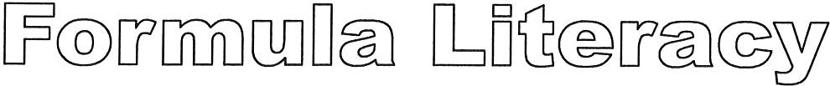
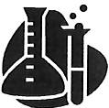
It is vital to be formula lit erat e as a ch em ist. You should be able to name subst ance s from their formulas, and should know or be able to work out the formula of many sub st ances.
You are exp ect ed to KNOW the information on these two pages and will betest ed on it frequently. You
WILL do far better in Chemistry if you are formula literate.

Elements |  |  |  | Compound s
H2 | hydrogen helium lithium carbon  nit rog en o xygen fl uorin e neon sodium  magnesium aluminium silicon phosphorus sulfur chlorine argon  pot assium calcium | Ti | titanium vanadium chromium mangan ese iron  cobalt nickel copper zinc bromine silver  tin iodine tungsten platinum gold mercury | H20 water  NH₃ ammonia H2S0 4 sulfuric acid HN03 nitric acid  HCI hydro chlori c acid NaOH sodium hydroxide co carbon monoxide CO2 carbon dioxide  NO nitrogen monoxide  N02 nit ro g en dio xide S0 2 sulfur dioxide  S0 3 sulfur t rioxide H2S hydrogen sulfide CH4 m e th ane  NaCl sodium chloride CuS0₄ copper sulfate AgN03 silver nitrate CaC0₃ calcium carbonate
He |  | V
Li |  | Cr
C |  | Mn
N2 |  | Fe
0 2 |  | Co
F2 |  | Ni
Ne |  | Cu
Na |  | Zn
Mg |  | Br₂
Al |  | Ag
Si |  | Sn
P4  Ss |  | 12  w
C'2 |  | Pt
Ar |  | Au
K |  | Hg
Ca

 | Group 1 ions |  | Group 2 ions |  |  | Group 3 ions |  |  |  | Oth ers
 | u+ | lithium | Mg2+ | magne sium |  |  | Al3+ | aluminium |  | NH/ | ammonium
 | Na+ | sodium | Ca2+ | calcium |  |  |  |  |  | Ag+ | silver
POSITIVE | K+ | pot assium | Ba2+ | barium |  |  |  |  |  | Cu2+ | copper (II}
IONS |  |  |  |  |  |  |  |  |  | Fe2+ | i ro n (II)
 |  |  |  |  |  |  |  |  |  | Fe3+ | ir o n (Ill }
 |  |  |  |  |  |  |  |  |  | Zn2+ | zin c
 |  |  |  |  |  |  |  |  |  | Pb2+ | lead
 | Group 6 ions |  |  | Group 7 ions |  |  |  |  | Others
NEGATIVE | o 2-  52· | ox ide sulfid e |  | F  er | fluoride chlorid e |  |  |  | O.H  N03. | hydro xide n i t r at e
IONS |  |  |  | Br' | bromide |  |  |  | so / | sulfate
 |  |  |  | r | iodide |  |  |  | ( 03. 2 | carbonat e
 |  |  |  |  |  |  |  |  | HC0 ·3 | hydroge | ncarb onat e

5

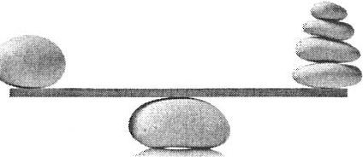
Putting together an ionic formula:

The charges must balance.
Molecular ions will need to be contained in brackets.

e.g.
There is 1+ and 2-

So we need:
K+ K+ to balance the 0 2
-
Giving the formula
K20
02
Oxide ion -
Potassium ion K+

Potassium Oxide

Aluminium Hydroxide
There is 3+ and 1- So we need:
O-H O-H OH- to balance the Al+³ Giving the formula
Al(OHh
Hydroxide ion
Aluminium ion Al³
+

Ammonium Phosphate
There is 1+ and 3- So we need:
NH/ NH/ NH/ to balance the PO/­
Giving the formula
(NH4hP03
Phosphate ion
Ammonium ion NH/

Lithium Nitride
There is 1+ and 3- So we need:
Lt Lt li+ to balance the N³
-
Giving the formula
li3N
N3
Nitride ion ₋
Lithium ion Li+

6

EXERCISE 1 Write the formulae of the following substances (a mixture of structure types, not just ionic)

- Sodium Chloride 11. Copper (I} Oxide

- Sodium Hydroxide 12. Nitrogen

- Sodium Carbonate 13. Sulfur trioxide

- Sodium Sulfate 14. Iron (II} Oxide

- Magnesium Chloride 15. Iron (Ill} Oxide

- Carbon Dioxide 16. Ammonium Nitrate

- Magnesium Hydroxide 17. Ammonium Sulfate

- Aluminium Chloride 18. Silver

- Aluminium Sulfate 19. Aluminium Oxide

- Copper (II} Sulfate 20. Calcium

EXERCISE 2 Give the names of these substances

- H2O  - co  - NH3  - NaH | 11. Li2SO4  - . CuSO4  - . AgNO3  14. (NH4}iSO4
5. CH4 | 15 . NH4VO3
6. HNO3 | 16. KMnO4
7. NaNO3 | 17.Co
8. Caci | 18. Kl
9. so | 19. Co(NO3)
10 . Li2S | 20 . KAt
 |  | 7

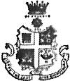

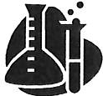
Structure types often called crystal t ypes
You should also be able to identify what type of structure a substance has from just its name/ formula - this is a KEY SKILL.
At GCSE level we are introduced to the concept that non-metals are held together (usually) by covalent bonds and that metal and non-metals are (usually) held together by ionic bonds. This will be developed further at advanced level. But let' s get the GCSE sort ed first!

Structure type | Which substances
Mon atomic | Group O elements
Simple molecular | Some non-metal elements (e.g. H2, N 2, 0 2, F2, P4, S_{8,} Cl2, Br2, 12) Compounds made from non-metals (e.g. NH3, CO2, H2O, C₆H12O₆, CH4)
Giant covalent  or Macromolecular | Diamond (C), graphite (C), graphene (C), silicon (Si), silicon dioxide (SiO 2)
Ionic | Compounds made from metal+ non-metals (e.g. NaCl, Fe2O3, CuSO4)
Metallic | Metals (e.g. Cu, Fe, Al, Na, Ca, Mg, Au, Ag, Pt)

EXERCISE 3 Identify the structure types of the following substances

- Sodium oxide 11. co

- Graphite 12. Co

- Bromine 13. NaNO3

- Copper nitrate 14. Fe

- Argon 15.Ss

- Iron chloride 16. CaSO4

- Calcium 17. H2

- Oxygen 18. SiO2

- Fluorine 19. Na

- . Wat er 20. Kr

8

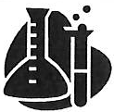
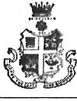
Many substances are acids, bases or salts. It is another KEY SKILL for any chemist that you can identify
which substances are which (not all substances are acids, bases or salts).

Nature | Which substances
Acid | Substances that release H+ (aq) ions when added to water, e.g. Hydrochloric acid (HCI) react to form chloride salts Sulfuric acid (H2S04) react to form sulfate salts  Nitric acid (HN0 ₃₎ react to form nitrate salts  Phosphoric acid (H₃P0 4) react to form phosphate salts
Base | Substances that react with acids to form a salt & water (and sometimes CO2)  Metal oxides (e.g. calcium oxide, iron oxide, copper oxide, nickel oxide, etc.)  Metal hydroxides (e.g. sodium hydroxide, calcium hydroxide, potassium hydroxide)  Metal carbonates (e.g. sodium carbonate, copper carbonate, calcium carbonate)  Metal hydrogencarbonates (e.g. calcium hydrogencarbonate, sodium hydrogencarbonate)  Ammonia (NH₃₎
Alkali | Substances that release OH-(aq) ions when added to water, e.g.  Metal hydroxides (e.g. sodium hydroxide, calcium hydroxide, potassium hydroxide)  Ammonia (NH₃₎
Salt | Ionic substances made when acids react with bases, e.g.  Nitrates (e.g. calcium nitrate, silver nitrate, potassium nitrate, ammonium nitrate)  Sulfates (e.g. copper sulfate, sodium sulfate, calcium sulfate, ammonium sulfate)  Chlorides (e.g. sodium chloride, potassium chloride, calcium chloride, ammo' nium chloride)  Bromides (e.g. lead bromide, potassium bromide, iron bromide) Iodides (e.g. potassium iodide, magnesium iodide, calcium iodide)  Phosphates (e.g. sodium phosphate, calcium phosphate, ammonium phosphate)

EXERCISE 4
For each of the substances below:
- give its name or formula if missing (use the ion charges on the data sheet to help)
- decide whether it is an acid, a base, an alkali or a salt ( the colum(s) - some may belong to more than category).
Name | Formula | Acid | Base | Alkali | Salt
calcium carbonate
copper (II) chloride
sulphuric acid
sodium sulfate
silver nitrate
phosphoric acid | H3PO4
 | cao
 | KOH
ethanoic acid | CH3COOH
sodium ethanoate | CH3COONa
 | Na NO3
 | HNO3
hydrochloric acid
ammonia
ammonium nitrate
ammonium sulfate
barium hydroxide
lead bromide
zinc phosphate | Zn3(PO4h
nickel carbonate
Copper (II) oxide
lithium hydroxide
iron (Ill) sulphate
magnesium chloride

10

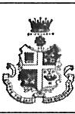

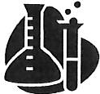
You will very rarely be asked to write word equations at Advanced Level. This is because you are expected to always write balanced symbol equations. However, to be able to write the symbol equations you need to know your word equations first!

Some common reaction equations:

Acid and alkali:
acid + alkali + salt + water
  - An example is hydrochloric acid + sodium hydroxide -+ sodium chloride + water

Acid and metal oxide:
acid + metal oxide + salt + water
  - An example is sulfuric acid + copper oxide -+ copper sulphate + water

Acid and metal carbonate:
acid + metal carbonate + salt + water+ carbon dioxide
  - An example is hydrochloric acid + calcium carbonate -+ calcium chloride + water+ carbon dioxide

Acid and metal:
acid + metal+ salt + hydrogen
  - An example is sulfuric acid + zinc -+ zinc sulphate + hydrogen

Metal and oxygen:
metal + oxygen + metal oxide
  - An example is magnesium + oxygen -+ magnesium oxide

Metal and sulfur:
metal + sulfur + metal sulfide
  - An example is iron + sulfur -+ iron sulfide

Metal and water:
metal + water + metal hydroxide + hydrogen
  - An example is calcium + water -+ calcium hydroxide + hydrogen

Combustion of hydrocarbon:
hydrocarbon + oxygen + carbon dioxide + water
- An example is methane + oxygen -+ carbon dioxide + water

Ionic equations of some common reactions
Acid + metal hydroxide salt | + water |  |  | H+ + O-H | H20
Acid + metal carbonate salt | + water | + | carbon | 2 H+ + C03- 2 | H20+ CO2
dioxide
Acid + metal hydrogencarbonate carbon dioxide | salt | + | water + | H+ + HC03- | H20 + CO2
Acid + ammonia ammonium | salt |  |  | H+ + NH3 | NH/

EXERCISE 5

Write complete word equations for the following reactions:

- Aluminium reacting with sulfur

- Copper burning in oxygen

- Ethane {CH3 CH3) burning completely in oxygen

- Ethanol (CH3CH20 H) burning completely in oxygen

- Lithium reacting with water

- Magnesium reacting in nitric acid

- Potassium oxidising in the air

- The reaction of calcium hydroxide with hydrochloric acid

- The reaction of sodium oxide wit h sulphur ic acid

- Zinc carbonate reacting with hydrochloric acid

12..

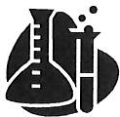

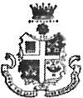
Balancing equations

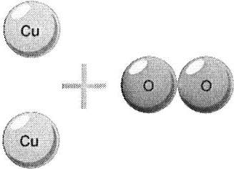
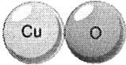
In a chemical reaction atoms are rearranged. They can't disappear or appear from nowhere. You must have the same number of each type of atom on each side of the equation

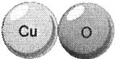
2Cu + 0 ₂ 2Cu0

REMINDER: There are a number of video clips to explain this principle linked on the contents page.

EXERCISE 6
Write balanced equations for the reactions in EXERCISE 5

1.

2.

3.

4.

5.

6.

7.

8
9.
10.

EXERCISE 7
Write balanced equations for the following reactions (including state symbols):
(aq) aqueous
- dissolved in water
(g) gas
(I) liquid
(s) solid
Remember:

  - Zinc metal reacts with copper (II) sulphate solution to produce solid copper metal and znc sulphate solution

  - Solid calcium hydroxide reacts with solid ammonium chloride on heating to produce solid calcium chloride, steam and ammonia gas.

  - When lead(II) nitrate is heated in a dry tube lead (II) oxide, nitrogen dioxide gas and oxygen are produced.

  - Silicon tetrachloride reacts with water to produce solid silicon dioxide and hydrogen chloride gas.

  - When octane (C₈H₁₈ ) vapour is burnt with excess air in a car engine carbon dioxide and water vapour are produced through a complete combustion reaction.

  - All the halogens apart from fluorine react with concentrated sodium hydroxide solution to produce a solution of NaX, NaXO₃ and water . Write an equation for the reaction of bromine with concentrated sodium hydroxide.

  - The elements of group 1 of the periodic table all react with water to produce a solution of the metal hydroxide and hydrogen gas. Write an equation for the reaction of lithium with water.

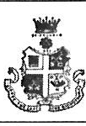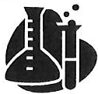

Rearranging allows us to show the same relationship in a different way.

So,

and

and

moles concentration x volume
moles
=
concentration l
vo ume

moles volume concentratwn
= .

When rearranging, whatever you do to one side of the equation you must do to the other side.

mass = Mr x moles
Rearranging to make Mr the subject involves+ both sides by moles

mass Mr x moles moles moles

So,
Mr= mass moles

EXERCISE 8

Rearrange the following equations to give the letter shown as the subject:

q = mcT | T= | x2 + bx - 1 | b=
pV - nRT | R= | X - b ² - 4ac | b=
G = H-TS | s = | 2a - 3(b - 4c) | b=
f = ma | m= | x2 + b -- 1 | x=
d - g  -  V | v= | X - b² - 4ac | a=
r -- m  -  t | t= | 2a - 3(b - 4c) | c=
[P Cl 3 ] [Cl2 ]  Kc = | [Clz] = | H - -log K | K=
[P Cl ₅ ]
15

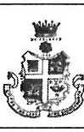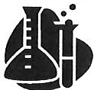

You will generate many long numbers in chemistry over the next two years! It is important to round these correctly using significant figures. When you make a measurement in chemistry you can indicate how uncertain it is by the number of significant figures. For example a volume of 5.0 cm³ has been measured
using equipment which can be read to 0.1cm³ whereas a volume of 5.00cm³ cm³ has been measured using
,

equipment which can be read to 0.01cm³
•
The numbers are different.

To find the number of significant figures of a value

Count the number of significant figures from the first non-zero digit.
  - Stop at the last non-zero digit OR the last digit after a decimal point.

484.23 | 5 sig fig
20.9 | 3 sig fig
290 | 2 sig fig
29.0 | 3 sig fig | (A zero after a decimal point is significant)

EXERCISE 9
To how many significant figures are these values recorded?

1.74 |  | 133.0
436 |  | 3.6 X 10·6
5.38000 |  | 4.25 X 107
9.20 |  | 82 X 109

When combining numbers in a calculation (using multiplication and division)your final answer can be no more certain than the least certain of the information you used to calculate the value.

Example: Calculate the number of moles in 43.85g of Mg (Ar= 24.3)

mass
Moles = Ar

43.85
24.3

the calculator value is 1.804526749
We need to round the value to the data value with the fewest significant figures in the calculation.

= 1.80 to 3s.f.

EXERCISE 10
Give the answers to these calculations to the appropriate number of significant figures.
    - What is the mass of 2 moles of water {H₂0 ) Mr 18.0?

    - What is the rate of a reaction which produces 25 ml of gas in 42 seconds?

    - A reaction produced a 3.886g yield of cyclohexene. The theoretical yield was 4.25g. What is the percentage yield of cyclohexene?

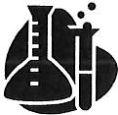
    - How much mass is lost per second if a reaction loses 23.995g in 48 seconds?

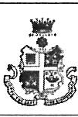
Standard form is used to express very large and very small numbers.

5366000
0.00000000897

Standard form must always be presented like this:
5.36 X 106

8.97 _{X} 10 -9

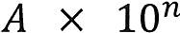

Where A is a number between 1 and 10
and n is the number of places the decimal point has 'moved'.
The same number of significant figures must be kept when converting between forms.

EXERCISE 11
Convert these values to standard form

156 000 000 |  | 0.03445
0.000345 |  | 481 000
100.3 |  | 0.000689012

I 7

Convert these values to ordinary form

6.02 X 103 |  | 3.65 X 106
4.2 X 10·2 |  | 6.778 X 10·3
1.99 X 105

Prefixes

Unit prefixes are used to give information about the standard form of a value. You will often need to convert different units for different equations, or just to make them easier to handle.

The most common in advanced level chemistry are:

Prefix | Conversion fact or | Symbol
milli | 10·3 | m
centi | 10"2 | C
deci | 10·1 | d
kilo | 103 | k

To convert a number to a base unit, convert the number into standard form and then multiply by the conversion factor.
This diagram shows the common mass conversions:

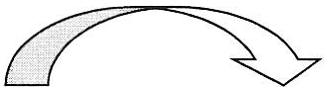
X 10³ 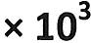 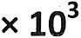

tonne kilogram gram milligram
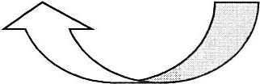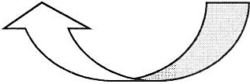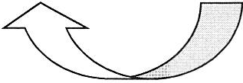
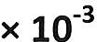
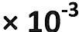
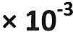

Other common conversions are between these volume prefixes:

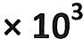
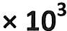
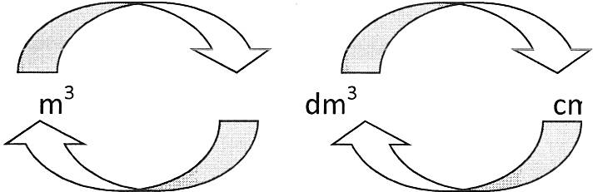
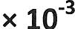
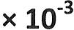
cm3

18

EXERCISE 12
Convert these values into the units given, give answers in standard form.

 | in grams |  | in cm3
13.5 tonnes |  | 0.025dm3
0.000235kg |  | 14.3m3
315mg |  | 0.000412m3
0.567t |  | 256dm3

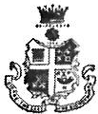

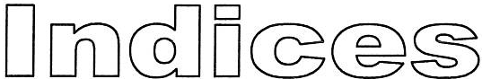
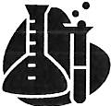
Indices or powers tell you how many times to multiply a number by it self.

I 3 ⁶ = 3 x 3 x 3 x 3 x 3 x 3 = 729

A negative power is the same as 1 over the positive version of the power

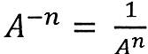 [r 2 = 3 = 0.111 to 3s. f.
3

When multiplying two numbers with the same base add the powers together
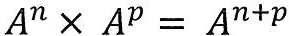

When dividing two numbers with the same base, subtract the powers.
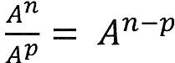

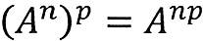
And finally,

EXERCISE 13

az  - --  a3 |  | a- 6  a 7 x a 2 --
a 2 x a 3 -  az - |  | a b- 3 c- 1 -  (ab-3)3 -

19

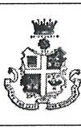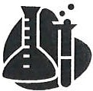
Graphs show us the relationship (or lack of) between variables.
General rule s are listed below, there may be deviation s from these on occasion but changes will usually be highlighted to you.
- Identify your independent variable (x axis) and the dependent variable (y axis).
- Choose a sensible scale and if necessary allow for extrapolation.
- Draw and label your axes including the units ( in the form variable/units)
- Plot your points with a neat sharp point.
- Draw a line of best fit.
Then you need to be able to manipulate and use that data!

EXERCISE 14
Experiment: Marble chips were added to a conical flask containing 2.0 moldm- ³ hydrochloric acid. The mass change was measured over time and recorded in a table.
Time/s | Loss in mass/g
0 | 0.000
10 | 0.018
20 | 0.048
30 | 0.081
40 | 0.116
50 | 0.143
60 | 0.158
70 | 0.165
80 | 0.165
90 | 0.165

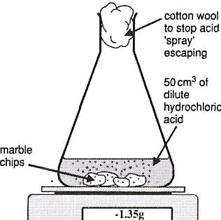

balance(reading to 0.01g)

      - Draw a graph of this data

      - How long would it take to lose 0.150g of mass?

      - Between 20 and 50 seconds what is the rat e of mass lo ss?

      - What is the rate of mass lo ss between 75 and 85 seconds ?

1..0

Experim ent: Sodium carbonate was reacted with nitric acid and the gas produced collected over time. The following results were obtained:

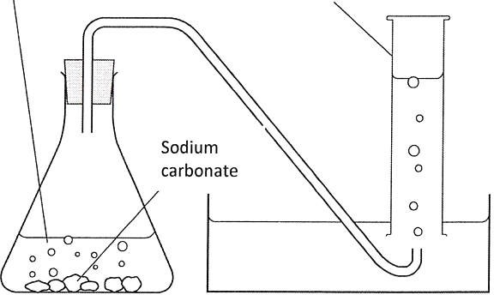
nitri c acid
Time/s | Volume of gas produced/ cm³
0 | 0
10 | 8
20 | 28
30 | 52
40 | 78
so | 87
60 | 106
70 | 123

- Plot a graph of time/s against volume of gas produced / m³
•
- What would you expect the gas volume to be at 80seconds?

- What would you expect the gas volume produced to be at 43 seconds?

- What would you expect the gas volume to be at lOseconds?

measuring cylin der

- What is the rate of gas production between 42 and 62 second s?

2.l

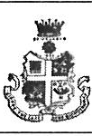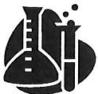

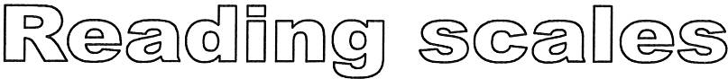
It may seem a little straight forward but somet imes they can be tricky. So just to make sure here are some examples of scales to read and if you get any wrong investigate your error in depth.
Exercise 15
0 0.1 0.2 ♦ 0.3
1)
I I I I I I I I I I I I I I I I I I I I, I,1 I I I I I I I I
2) --0.3 --0.2 --0.1 ♦ 0
I I I I I I I I I I I I,I I I I 11 I I I I I I I I I I I I I

-3 -2 -1 0
3)

4)

cm ³
5) 6) 0
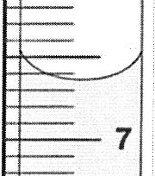
27 =0.
6

cm 3 oc
2 0
a)

8) 9)
7)

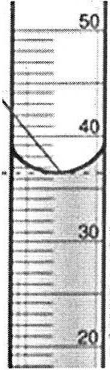
cm³

100

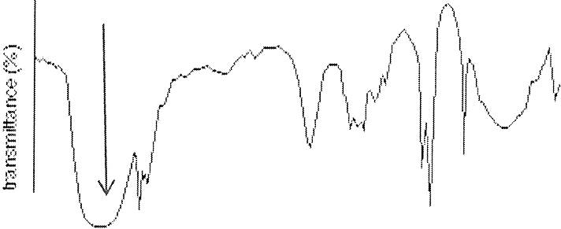
( 2)

I) -+-,,- "T'T"'S..,....,...,-,--,......,..-,--.,......,..--,-.,....,..--,--,-,,--,--,-,, ,--
.,..- - 1--- - - y-i,- ....- .--""T""-,..-

4CIOO 2000 1CICIO SQQ
v1,iw,nwnl:i,w (cr-n-1)
$.0 40 3.0 2.0 1,0 0
6 ppm

1.2.

ANSWERS TO EXERCISES
Answers Ex 1 Writing formulae from names:
  - Sodium Chloride NaCl 11. Copper (I) Oxide Cu20

  - Sodium Hydro xid e NaOH 12. Nitrogen N2

  - Sodium Carbonate Na2C03 13. Sulfur trioxide S03

  - . Sodium Sulph ate Na2S04 14. Iron (II) Oxide FeO

  - Magnesium Chl oride M gCl2 15. Ir on (Ill) Oxide Fe20 3

  - Magnesium Nitrate Mg(N03)i 16. Ammoni um Nitrate NH₄N03

  - M agnesium Hydro xid e Mg(OH)i 17. Ammonium Sulphate (NH4)i S0 4

  - Aluminium Clhoride AICl3 18. Silv er Ag

  - Aluminium Sulph ate Al2(S0 4h 19. Aluminiu m Oxide Al20 3

  - Copper (II) Sulp h ate CuS04 20. Calcium Ca

Answers Ex 2 Writing names fr om formu lae:

- H20 Wate r 11. Li2S0 4 Lithium Sul fate

- CO2 Carbon Dioxide 12. CuS04 Copper Sul fate

- . NH 3 Ammonia 13. AgN03 Silver nitrate

- NaH Sod ium Hydride 14. (NH4)i S04 Ammonium sulphate

- CH4 Methane 15. NH4V03 Ammonium vanadate

- HN0 3 Nitric Acid 16. KM n0 4 Potassium Manganate

- NaN0 3 Sodium Nit rat e 17. Co Cobalt

- CaCl2 Calcium chl oride 18. Kl Potassium Iodide

- S02 Sulphur Dioxide 19. Co(N0 3)i Cobalt Nitrate
- Li2S Lith ium Sulfid e 20. k'.Al Potassium Astatide
Answer s Ex 3

1. Sodium oxide | Ionic | 11. co | Simple Molecular
2. Graphite | Giant Covalent | 12. Co | Monatomic
3. Bromine | Simpl e Molecular | 13. NaN03 | Ionic
4. Copper nitrate | Ionic | 14. Fe | Monatomic
5. Argon | Monatomic | 15. Sa | Simpl e M o le cular
6. Iron chlori de | Ion ic | 16. CaS04 | Ionic
7. Calcium | Metallic | 17. H2 | Simple Molecular
8. Oxygen | Simple Molecular | 18. Si0 2 | Giant Covalent
9. Fluorin e | Simple Molecular | 19. Na | Monatomic
10. Water | Simple M olecular | 20. Kr | M onat omic

Answers Ex 4

Name | Formula | Acid | Base | Alkali | Salt
calcium carbonate | CaC03
copper (II) chloride | CuCl2
sulphuric acid | H2S04
sodium sulfate | Na2S04
silver nitrate | AgN0 3
phosphoric acid | H3P0 4
calcium oxide | cao
potassium hydroxide | KOH
ethanoic acid | CH3COOH
sodium ethanoate | CH3COONa
Sodium nitrate | NaN0 3
nitric acid | HN03
hydrochloric acid | HCI
ammonia | NH3
ammonium nitrate | NH4N0 3
ammonium sulfate | (NH4 }i S04
barium hydroxide | Ba(OH)i
lead bromide | PbBr 2
zinc phosphate | Zn3(P04)i
nickel carbonate | NiC03
Copper (II) oxide | CuO
lithium hydroxide | LiOH
iron (Ill) sulphate | Fe2(S04h
magnesium chloride | MgCl2

Answers Ex S and 6

Aluminium + Sulfur Aluminium Sulfide Copper + Oxygen Copper (II) Oxide Ethane + Oxygen Carbon dioxid e + Water Ethanol + Oxygen Carbon dioxide + Water
Lithium + Water Lithium hydroxide + Hydrogen Magnesium + Nitr ic acid Magnesium nitrate + Hydrogen Potassium + Oxygen Potassium Oxide
Calcium Hydro xide + Hydrochloric acid Calcium chloride + Water Sodium Oxide + Sulphuric acid Sodium Sulphate + Water
Zinc Carbonate + Hydrochloric acid Zinc chloride + Carbon dioxide + Water
2AI + 3S Al2S3
Cu + ½ 0 2 CuO
CH3CH3 + 3½02 2C02 + 3H20 CH3CH20 H + 302 2C0 2 + 3H20 Li + H20 LiOH + ½ H2
Mg + 2HN03 Mg(N03)i + H2
2K + ½ 0 2 K20
Ca(OH)i + 2HCI CaCl2 + H20 N a20 + H 2S0 4 Na2S0 4 + H 20
ZnC0 3 + 2HCI ZnCl2 + CO2 + H 20

Ex 7

Ex8

- Zn(s) + CuS0₄(aq) ZnSO₄(aq) + Cu(s)
- Ca(OH)z(s) + 2NH₄CI CaCli(s) + 2H2O(g) + 2NH₃(g)
3. Pb(NO ₃}i(s) Pb O(s) + 2NO2(g) + O2(g)
4. SiCl₄(1) + 2H2O(1) SiO 2( s) + 4HCl(g)
5. CaH1 s(g) + 12½O2(g) 8C02(g) + 9H2O(g)
- 3Br2 + 6NaOH(aq) SNaBr(aq) + NaBrO₃(aq) + 3H2O(1)
- 2Li(s) + 2H2 O(I) 2LiOH(aq) + Hi{ g)

q = mer | T=.!!....  m e |  |  | x 2 + bx = 1 |  |  |  | 2  b = -1- x  X
pV = nRT | R =E.".  111' |  |  | X | = | b' - 4ac |  | b = x + 4ac
G = H-TS | S = | H-G  T |  |  |  | 2a | = 3(b- 4c) | b=2a + 4c  3
f = ma | m=[_  a |  |  | x 2 + b = 1 |  |  |  | x=-lf=b
d = f!_  V | v=!!.  d |  |  | X | = | b2 - 4ac |  | b2- x  a=--  4c
r = m  -  t | t =!,'..! |  |  |  |  | 2a | = 3(b- 4c) | c=3b-2a  12
[ P C13l[C12 ]  Kc= [PC1 ] 5 | [Ch] |  | Kc[PCl s]  (PC1₃ ] | H = -log K |  |  |  | K=10-H

Ex9

1.74 | 3 | 133.0 | 4
436 | 3 | 3.6 _{X} 10·6 | 2
5.38000 | 6 | 4.25 X 107 | 3
9.20 | 3 | 82 _{X} 109 | 2

Ex 10
  - 40g to 1 sf (sf ve ry important!)
2) 0.60 m1·s ¹ to 2 s f
3) 91.4% to 3sf
- 40.S0g to 2sf

Exll

156 000 000 | 1.56 X 108 | 0.03445 | 3.445 X 10·2
0.000345 | 3.45 _{X} 10·4 | 481 000 | 4.81 X 105
100.3 | 1.003 X 102 | 0.000689012 | 6.89012 _{X} 10·4

6.02 X 103 | 6020 | 3.65 X 10 6 | 3650000
4.2 _{X} 10·2 | 0.042 | 6.778 _{X} 10·3 | 0.006778
1.99 X 105 | 199000

Ex 12

 | in grams I | in cm3
13.5 tonnes | 1.35 X 107 I 0.025dm3 | 2.5 X 101

).'5

0.000235kg | 2.35 X 10-1 | 14.3m 3 | 1.43 X 107
315mg | 3.15 X 10-1 | 0.000412m3 | 4.1 2 X 102
0.567t | 6.67 X 105 | 256dm3 | 2.56 X 105
EXERCISE 13

az -  -a3 - | a - 1 | a-6 -  a 7 x a 2 - | a - 1 s
a 2 x a 3  a2 -- | a3 | a b- 3c- 1  (a b - 3) 3 - | a-2b6c-1

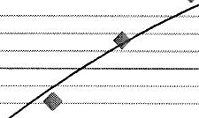
EXERCISE 14

0.2  0.15 .... ..---  QI)  ....... 0.1  ""IQ''  E  .!: /  /  ""'' 0.05 , / T  .2 /  ..... /  0 '/  II "0  -0.05  time/s |  | 2) 55s  3) 3.17 X 10-3 g-sI  4) 0.00 g-s I

20

0
I -- -- ----10 ----- : L(j .·--·-··-- -·-·3(: f - ---40-- - - - 50 -- · · 60 : -·-· -70 S0
-20 - - - - - - - - - - - - - - - - - - - - -
Time/ s
40
0
>
0
60
QI)
.......
"IQ'
-
140

120

100
M
Eu 80
2) 140 cm³
3) 76 cm³
4) 14 s (from the graph not the data table)
5) 1.7 cm³-s ¹

Ex 15 Reading Scales
1) 0.23
2) -0.06
3) -2.6
4) 6.65cm³
5) 27.75 cm3
6) 87.5 °C
7) 36 .50 cm3
8) 3300cm· ¹
  - 2.6ppm

WHERE AM I? ANSWERS

    - Mg + 2HNO3 -+ M g(N O3)i + H2
    - Magnesium nitrate is an ionic compound, hydrogen is a simple molecular substance.
° =
    - :. 0 8.24g of magnesium nitrate is the theoretical yield
50
Therefore, moles of Magnesium nitrate and thus Magnesium= 0.0555
=
148.3
Mass of magnesium = 0.0555 x 24.3 = 1 . 35g to 3sf MUST BE TO 3 SF
    - 1300 3.10 cm 3 s- 1 MUST BE TO 3 SF
=
420
  - Magnesium oxide or Magnesium hydroxide
  - MgO + 2HNO3 -+ M g(N O3h + H2 O
or Mg(OHh + 2HNO3 -+ Mg(NO3h + 2H2O
or MgCO3 + 2HNO3 -+ M g(N O3h + H2O + CO2

  - 416g MUST BE TO 3 SF

21

