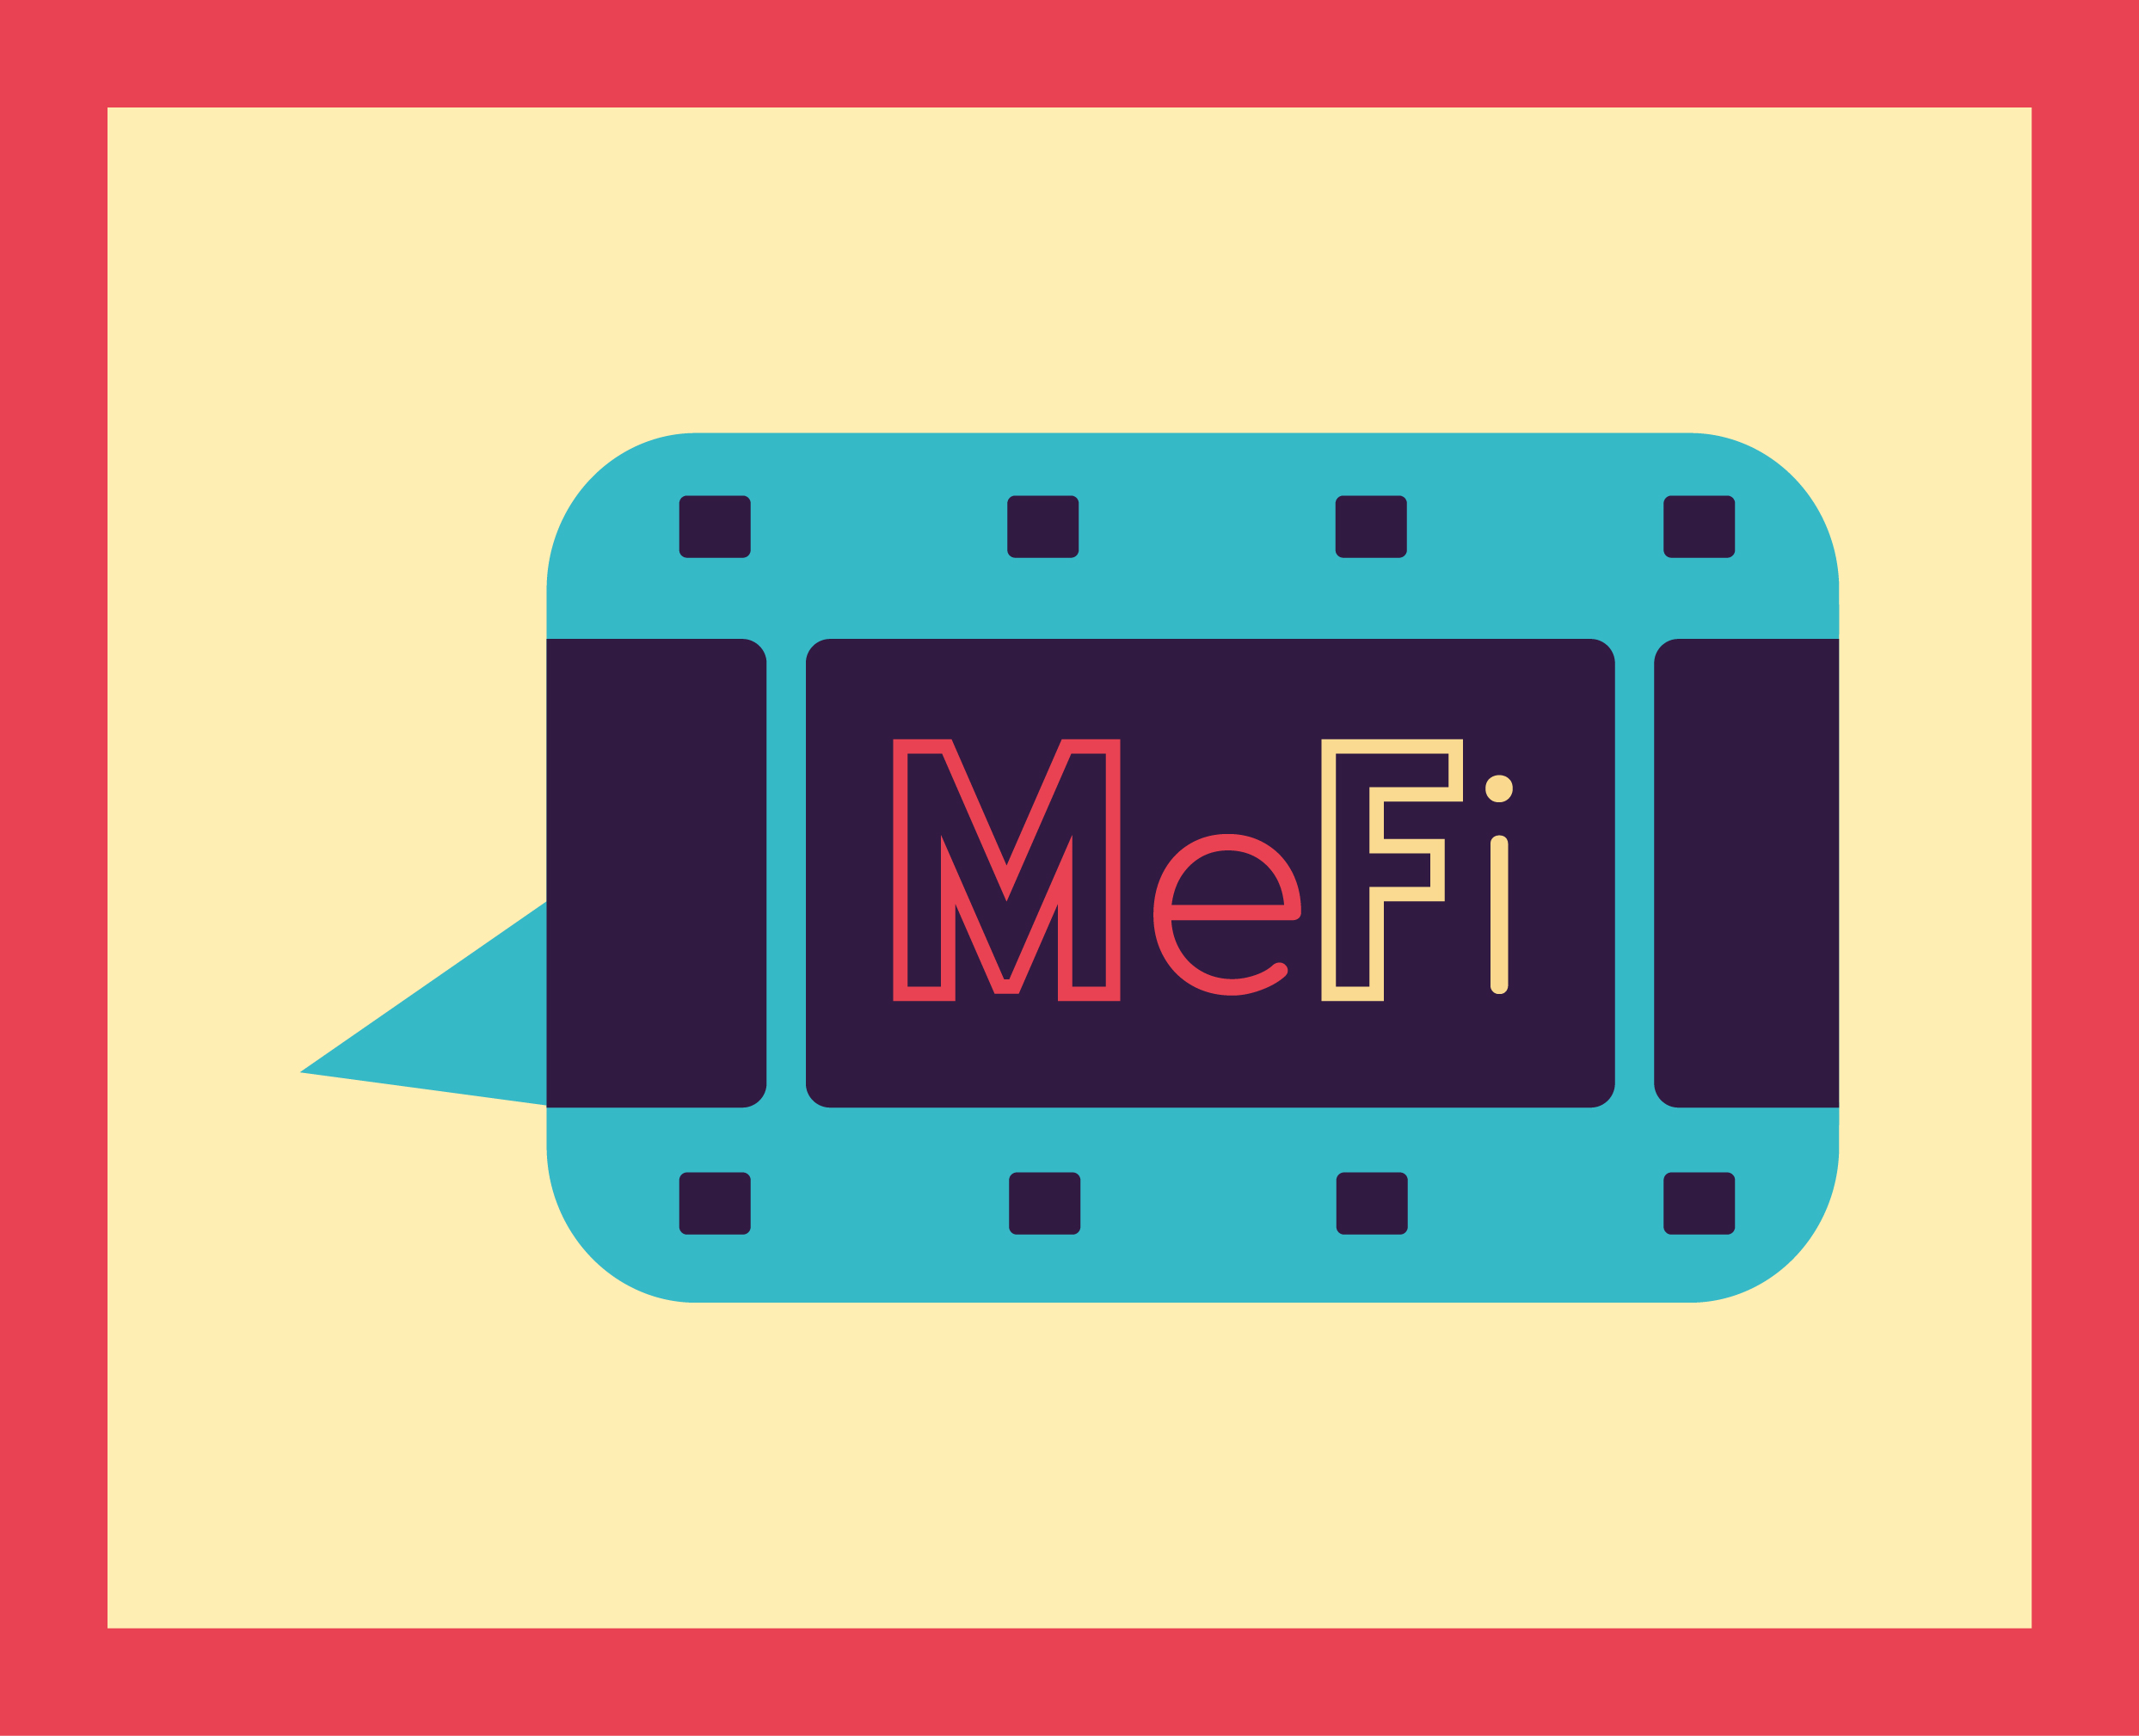
Cambridge Technical - Digital Media: Diploma (double) & Extended (single)
For any students who are considering taking Media as a Cambridge Technical next year, there are a few things you can do to prepare yourself!
The following will help to support the course:
- Watch some Photoshop tutorials, which will improve your skills. Hundreds can be found on YouTube (they're excellent) and on this website too: https://www.photoshopessentials.com
- Keep an eye on our MeFi YouTube account for tutorials and ‘how to’ videos: https://m.youtube.com/channel/UC1v5owi2lsRzi8_h9cE1mJQ
- Download a free 7 day trial of Photoshop to try out some new skills. You might want to produce a new magazine front cover and double page spread as this will be a coursework unit next year.
You might also want to create a mock up advertising campaign – produce a billboard and/or magazine advert promoting any product.
- You could make notes using the detail PowerPoint I have attached. It's all about textually analysing, which is a big focus on the Cambridge Technical Digital Media course. Those who have studied GCSE Media will be familiar with this PowerPoint.
Textually analyse your favourite scene from a film/TV show!
- This is the textbook you will need for the next academic year, so it might be worth reading through the units you will be studying.
Extended certificate (Single course) = 1, 2, 3, 21, 20 & 24
Diploma (Double course) = 1, 2, 3, 4, 6, 7, 9, 10, 16, 21, 20 & 24
Not all of the units are in the textbook, but the majority of them are https://www.amazon.co.uk/Cambridge-Technicals-Level-Digital-Media/dp/1471874737/ref=sr_1_1?crid=3KUTY6WRU3J1C&dchild=1&keywords=cambridge+technicals+level+3+digital+media&qid=1584981753&sprefix=cambridge+technical%2Caps%2C147&sr=8-1

