A Level Business Bridging Work
A Level Business is all about preparing you to be a manager / business owner to be able to carry out perceptive analysis and make the right key decisions – this is the focus of this bridging work.
Task 1 – Covid-19 Business winners & losers
Watch the following short video where one industry is highlighted as a ‘big loser’:
https://www.youtube.com/watch?v=ajK_mhAEsa8
Highlight some other industries/businesses that you feel are currently suffering the most but also consider those you feel are benefiting from the current crisis, the ‘winners’ if there can be said to be any in these times. [briefly explain why for each ‘winner’ you identify.
‘Winners’ | ‘Losers’
 | Airlines
Task 2 – Covid-19 Crisis Management
Overall businesses both large and small are suffering currently. You will learn in A Level Business that employees are the biggest asset of any business but also the biggest cost – businesses are struggling with how to deal with that biggest cost currently and have taken several different routes.
Option 1 – Sacking / sending employees home without any pay
https://tinyurl.com/r5q8u7n
Option 2 – Making some ‘less valued’ staff take a pay cut whilst the ‘more valued’ keep full pay
https://tinyurl.com/tevtlcm
Option 3 – Keeping most employees on full pay whilst directors take pay cut
https://tinyurl.com/s83m3r3

Management decision required
What option would you take if it were your business that has had to close down partially or completely
and it looks like you will struggle to survive? Consider the potential positive and negatives of your decision.
Option I would take:

Best option to take because:
Task 3
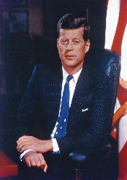
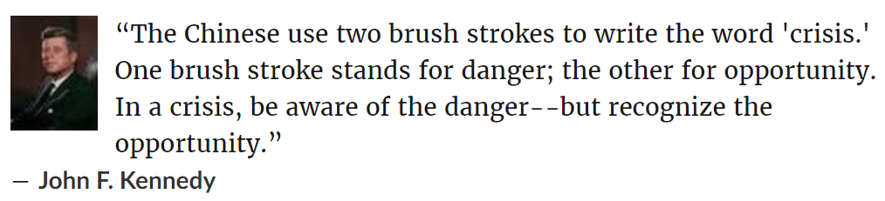
John F. Kennedy was right, out of disaster and hardship often comes opportunity. During the world wars in the early 20th century the following inventions came from them proving the fact:
- Canned Food. As Napoleon and his army romped across Europe, the General needed to find a way to deliver enormous quantities of good-enough food to the front lines.
- Plastic Surgery
- Sanitary Napkins
- Duck Tape
- Microwave Ovens
- Digital Photography
- The Internet

Imagine you have some capital (money to invest) to start a new business after the Covid-19 crisis is over. What do you think is the perfect business to start that will thrive on the other side – trust me there will be plenty of businesses that will more than thrive on the other side of this!
Create an outline business plan (very basic) detailing your business idea including:
- My Vision
- Aims & Objectives (1 / 3 / 5 years objectives are normal)
- Target Market (including market research)
- Competition Analysis
- Marketing Mix (Outline of product, place, price & promotion for your business idea)
- Financial Plan (can include break even, cash flow, profit & loss projections, start-up capital required etc.)
- Location (where will you be located? Will you be 100% online even?

