**Examples of acceptable girls’ shoes:-**

[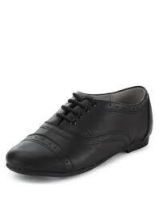](http://www.google.co.uk/imgres?imgurl=http://asset1.marksandspencer.com/is/image/mands/HT_04_T72_8509B_Y0_X_EC_0&imgrefurl=http://www.marksandspencer.com/l/kids/school-uniform/girls-uniform-school-shoes-and-trainers&h=400&w=308&tbnid=AOMu4u4650cmfM:&zoom=1&q=popular%20school%20shoes%202014&docid=qvK9cx-4A04KdM&itg=1&ei=tE5KVJPuCcTfaNypgMAC&tbm=isch&ved=0CCAQMygYMBg4yAE&iact=rc&uact=3&dur=1292&page=10&start=209&ndsp=25)[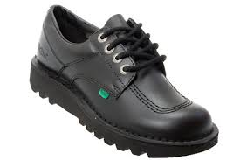](http://www.google.co.uk/imgres?imgurl=http://www.kcmode.com/ekmps/shops/kcmodeltd/images/kickers-youth-kick-lo-y-core-classic-boot-black-leather-boots-%5b2%5d-22796-p.jpg&imgrefurl=http://www.kcmode.com/kickers-youth-kick-lo-y-core-boot---black-leather-boots-22796-p.asp&h=333&w=500&tbnid=zMTDYkCThZ3LqM:&zoom=1&docid=G2nUD7hJgh_0MM&ei=bwVNVP7UB5Gp7AbSiYGgBQ&tbm=isch&ved=0CFUQMygVMBU&iact=rc&uact=3&dur=1207&page=2&start=19&ndsp=23)[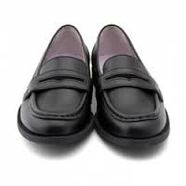](http://www.google.co.uk/url?sa=i&rct=j&q=&esrc=s&source=images&cd=&cad=rja&uact=8&ved=0CAcQjRw&url=http://www.boniclassic.com/gb/14-girls-shoes-casual&ei=JhRNVPKLIcveaqWrgJgG&bvm=bv.77880786,d.ZGU&psig=AFQjCNEKrNvnYgSJPxxDfRhKcpm7H5pDIw&ust=1414423886307234)

[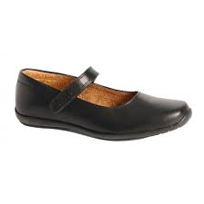](http://www.google.co.uk/url?sa=i&rct=j&q=&esrc=s&source=images&cd=&cad=rja&uact=8&ved=0CAcQjRw&url=http://www.charlesclinkard.co.uk/girls-c23/shoes-c24/1-p4275&ei=dxJNVODxN9XzapyQgOgJ&bvm=bv.77880786,d.ZGU&psig=AFQjCNH-ROCDDfzaoVbc2rRC2pnmQ_jlKQ&ust=1414423473990858)[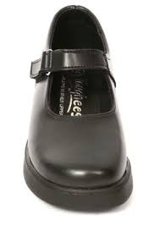](http://www.google.co.uk/url?sa=i&rct=j&q=&esrc=s&source=images&cd=&cad=rja&uact=8&ved=0CAcQjRw&url=http://www.tougheesshoes.co.uk/index.php?main_page=product_info&products_id=7&ei=vBRNVKzoDc7raKTvgMgO&bvm=bv.77880786,d.ZGU&psig=AFQjCNFvcLLu09Glflh0OhTHVVZl1Rnqaw&ust=1414424050159926)

**Examples of acceptable boys’ shoes:-**

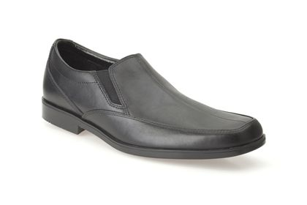[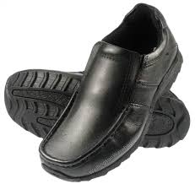](http://www.google.co.uk/url?sa=i&rct=j&q=&esrc=s&source=images&cd=&cad=rja&uact=8&ved=0CAcQjRw&url=http://www.ebay.co.uk/itm/Kids-Red-Tape-Ratcliffe-Black-Boys-Junior-Leather-School-Shoes-/271147841814&ei=AAZNVObNOoXfarzsgfgG&bvm=bv.77880786,d.ZGU&psig=AFQjCNEA8T61qjuNf3foDLBMUnwAncqwkQ&ust=1414420332119934)

[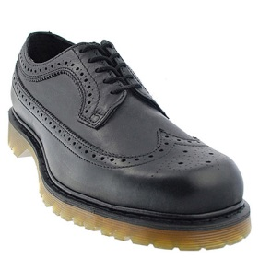](http://www.jamesandjames.com/pictures/drmartens/large/dm3989black.jpg)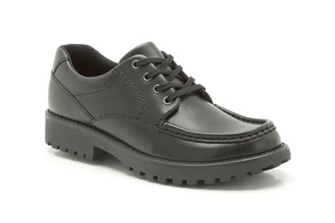[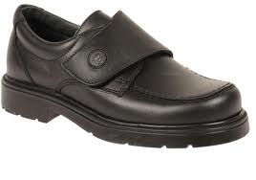](http://www.google.co.uk/url?sa=i&rct=j&q=&esrc=s&source=images&cd=&cad=rja&uact=8&ved=0CAcQjRw&url=http://www.alibaba.com/product-detail/BOYS-SCHOOL-SHOES_111819757/showimage.html&ei=5BFNVLy7H8OKaIiNgrAO&bvm=bv.77880786,d.ZGU&psig=AFQjCNFlohGJTckuO1_471QfJjZGQsW4fQ&ust=1414423365557864)

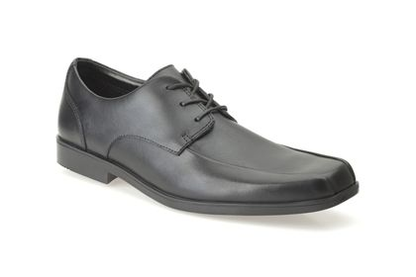

**Unacceptable shoe styles:**

* **any trainer or plimsoll style;**
* **shoes with a heel;**
* **boots.**

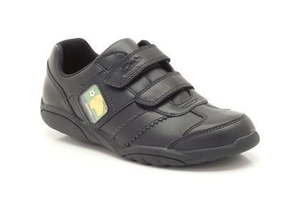[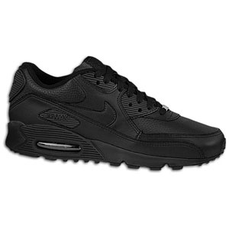](http://www.google.co.uk/url?sa=i&source=images&cd=&cad=rja&uact=8&ved=0CAgQjRw&url=http://www.footlocker.com/product/model:148253/sku:02519001/nike-air-max-90-mens/all-black/black/&ei=GAVNVIuwOrPG7AaAsoCgCA&psig=AFQjCNG3aQLCsK2ooUY_7cLscnXkF5JiFQ&ust=1414420121055163)

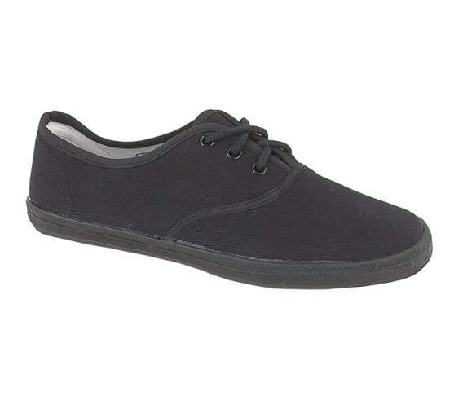

[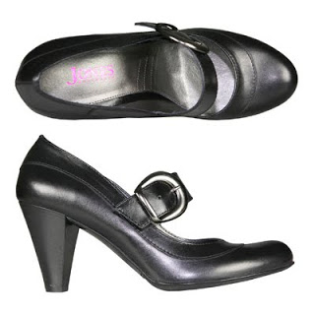](http://3.bp.blogspot.com/-66CQ9ORl9-M/T9wTP2vBOpI/AAAAAAAAAIU/ZwSgjez-KA4/s1600/School+Shoes.jpg)[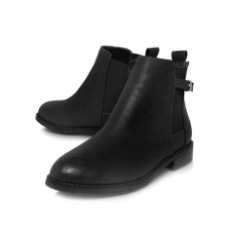](http://www.kurtgeiger.com/miss-kg-black-synthetic-39-sammy-shoe.html)